

**TRAINING MANAGEMENT SYSTEM**

**Software Requirement Specification**

R**ecord of change**

|  |  |  |  |  |  |
| --- | --- | --- | --- | --- | --- |
| **No** | **Date** | **Version** | **Change Description** | **Author** | **Reviewer** |
| 1 | 26/08/2022 | 1.0 | Start | BA PRAC |  |
| 2 |  |  |  |  |  |
| 3 |  |  |  |  |  |
| 4 |  |  |  |  |  |
| 5 |  |  |  |  |  |
| 6 |  |  |  |  |  |
| 7 |  |  |  |  |  |
| 8 |  |  |  |  |  |
| 9 |  |  |  |  |  |
| 10 |  |  |  |  |  |

# TABLE OF CONTENTS

**1. Introduction** **7**

1.1. Purpose 7

1.2. Scope 7

1.3. Definitions, Acronyms, and Abbreviations 8

Table 1.3_1: Menu name definition 8

1.4. References 8

1.5. Overview 8

Business Flow: 9

Flow 1.5_1: User Story 1 + 2 9

Flow 1.5_2: User Story 3 + 4 9

Flow 1.5_3: User Story 5 + 6 10

Flow 1.5_4: User Story 7 10

**2. Overall Description** **11**

2.1. Product Perspective 11

2.2. Product Functions 11

Table 2.2_1: Function list 12

2.3. User Characteristics 12

2.4. Constraints 13

**3. Specific Requirements**14

3.1. Functionality 14

Table 3.1_1: Icon meaning in Table Item definition 14

3.1.1. Use Case 1: Login 15

Figure 3.1.1_1: Login 15

Figure 3.1.1_2: EM1 15

Table 3.1.1_1: User story 16

Table 3.1.1_2: Item and event description 18

3.1.2. Use Case 2: List of Syllabus 18

Figure 3.1.2_1: List of Syllabus 18

Figure 3.1.2_2: Date picker calendar 19

Figure 3.1.2_3: Syllabus popup menu 19

Table 3.1.2_1: User story 19

Table 3.1.2_2: Item and event description 25

3.1.3. Use Case 3: Syllabus details 25

Figure 3.1.3_1: Syllabus details - tab General 25

Figure 3.1.3_2: Syllabus manage popup 25

Figure 3.1.3_3: Output standard tooltip 25

Figure 3.1.3_4: Syllabus details - tab Outline 26

Figure 3.1.3_5: Training material popup 26

Figure 3.1.3_6: Syllabus details - tab Others 27

Table 3.1.3_1: User story 28

Table 3.1.3_2: Item and event description 37

3.1.4. Use Case 4: Create New Syllabus 37

Figure 3.1.4_1: Create Syllabus - tab General 37

Figure 3.1.4_2: Create Syllabus - tab Outline 38

Figure 3.1.4_3: Create Syllabus - Delete day popup 38

Figure 3.1.4_4: Delivery Type 39

Figure 3.1.4_5: Training Material 39

Figure 3.1.4_6: Alert popup 40

Figure 3.1.4_7: Create Syllabus - tab Others 40

Table 3.1.4_1: User story 41

Table 3.1.4_2: Item and event description 50

3.1.5. Use case 5: List of Training Program 51

Figure 3.1.5_1: List of Training Program 51

Figure 3.1.5_2: Pop-up functions 52

Figure 3.1.5_3: List of Training Program (filtered) 52

Table 3.1.5_1: User story 52

Table 3.1.5_2: Item and event description 55

Table 3.1.5_1: User story 56

Table 3.1.5_2: Item and event description 58

3.1.6. Use Case 6: Training Program Details 59

Figure 3.1.6_1: Training Program Detail 59

Figure 3.1.6_2: Manage Training Program 60

Figure 3.1.6_3: Syllabus Detail 60

Figure 3.1.6_4: Go to Syllabus button 61

Figure 3.1.6_5: Output Standard 61

Figure 3.1.6_6: Tooltips for Delivery Type 61

Figure 3.1.6_7: Training Material popup 62

Table 3.1.6_1: User story 63

Table 3.1.6_2: Item and event description 70

3.1.7. Use case 7: Create Training Program 70

Figure 3.1.7_1: Create Training Program 70

Figure 3.1.7_2: Create Training Program_Add syllabus 1 71

Figure 3.1.7_3: Training Program_Syllabus popup 71

Figure 3.1.7_4: Create Training Program_Add syllabus 2 72

Table 3.1.7_1: User story 73

Table 3.1.7_2: Item and event description 76

3.1.8. Use case 8: List of Class 77

Figure 3.1.8_1: List of Class 77

Figure 3.1.8_2: Pop up Management of List of Class 77

Figure 3.1.8_3: Filter screen of List of Class 78

Figure 3.1.8_4: Screen Edit of List of Class 79

Table 3.1.8_1: User story 80

Table 3.1.8_2: Item and event description 81

3.1.9. Use case 9: Training Class Details 81

Figure 3.1.9_1: Training Class Details 82

Figure 3.1.9_2: Manage a Training Class 83

Figure 3.1.9_3: Delivery Type Tooltip 83

Figure 3.1.9_4: Trainer Information Tooltip 83

Figure 3.1.9_5: Class Detail Tooltip 83

Figure 3.1.9_6: Class Detail Collapse 84

Table 3.1.9_1: User story 85

Table 3.1.9_2: Item and event description 93

3.1.10. Use case 10: Create new training class 93

Figure 3.1.10_1: Create class name 93

Table 3.1.10_1: User story 93

Figure 3.1.10_2: Add training program general information 95

Figure 3.1.10_3: Add training program details 99

Figure 3.1.10_4: Add training program details for each Day (Content) 102

3.1.11. Use case 11: Training Calendar 104

Figure 3.1.11_1: Training Calendar main view 104

Table 3.1.11_1: User story 105

Table 3.1.11_2: Item and event description 106

Figure 3.1.11_2: Table Filter 107

Table 3.1.11_3: Item and event description 109

Figure 3.1.11_3: Class info - view 109

Table 3.1.11_4: Item and event description 110

3.1.12. Error message 110

3.2. Usability 110

3.3. Reliability 110

3.4. Performance 110

3.5. Supportability 110

3.6. Permission Management 111

3.7. Legal, Copyright, and Other Notices 112

3.8. Non-functional requirements 112

4. OUT OF SCOPE113

# 1. Introduction

This application is used for Fresher Academy to support create and management classes easily.

This website helps the operation staff of FA in managing and scheduling classes, with features as follow:

* Create and manage the syllabus's content.
* Create and manage training program.
* Plan and manage classes.
* Report classes by week, quarter.

## 1.1. Purpose

By expressing the SRS, the milestone of this application is providing an overview of the Class planning applications website.

This SRS is to describe a detailed process of creating, starting, closing and managing classes including:

* Business Flow
* Screen Design Document
* User Interface
* User Story (Note: we do not mention Acceptance criteria in this version, but Min and Max values for validation are mentioned in column Max length; Happy case and error case are mentioned in column Supplementary explanation of “Item and event description” table)

The functional requirements specification of this project are:

* Define the scope of business goals, business functions and organizational units to be covered.
* Define the business process that the solution must facilitate.
* Facilitate a common understanding of what functional requirements are for all stakeholders.
* Establish the basis for defining acceptance tests for the solution to confirm that what is delivered meets the requirements.

It also describes the non-functional requirements, design constraints, and other elements necessary to provide a complete and comprehensive description of the requirements for the software.

## 1.2. Scope

The scope of this SRS defines the action of the operation staff of FA in managing and scheduling classes. The experiencing flow start at:

1. Create and manage the syllabus's content.
2. Create and manage training program.
3. Plan and manage classes.
4. Report classes by week, quarter.

## 1.3. Definitions, Acronyms, and Abbreviations

This subsection provides the definitions of all terms, acronyms and abbreviations required to properly interpret the document.

|  |  |
| --- | --- |
| Acronym | Definition |
| Syllabus | Detailed description of training content. |
| Training program | It is created from many syllabuses. |
| Training class | It depends on different learners that there are different training programs. |
| Training calendar | Admin can view all training classes running. |

### Table 1.3_1: Menu name definition

## 1.4. References

This subsection provides a complete list of all documents referenced elsewhere in the SRS.

All the screens UI and mock-ups are stored at:

* <https://www.figma.com/file/GoBgMjMIsQqaEJAMoBCAgW/Warrior?node-id=49%3A199>

Input documents to write this SRS:

1. <https://fsoft-academy.edu.vn>
2. <https://fee.haui.edu.vn/media/29/uffile-upload-no-title29709.pdf>
3. <https://www.youtube.com/watch?v=skf7eW-YQ_E&t=5s&ab_channel=FPTSoftware>
4. <https://leowiki.com/review-fpt-software-academy-1639846318>

## 1.5. Overview

This subsection will lead users to go to details of SRS to determine the contents of SRS presented as formal documents. The SRS would help user catch up how to process of Class planning management

Business Flow:

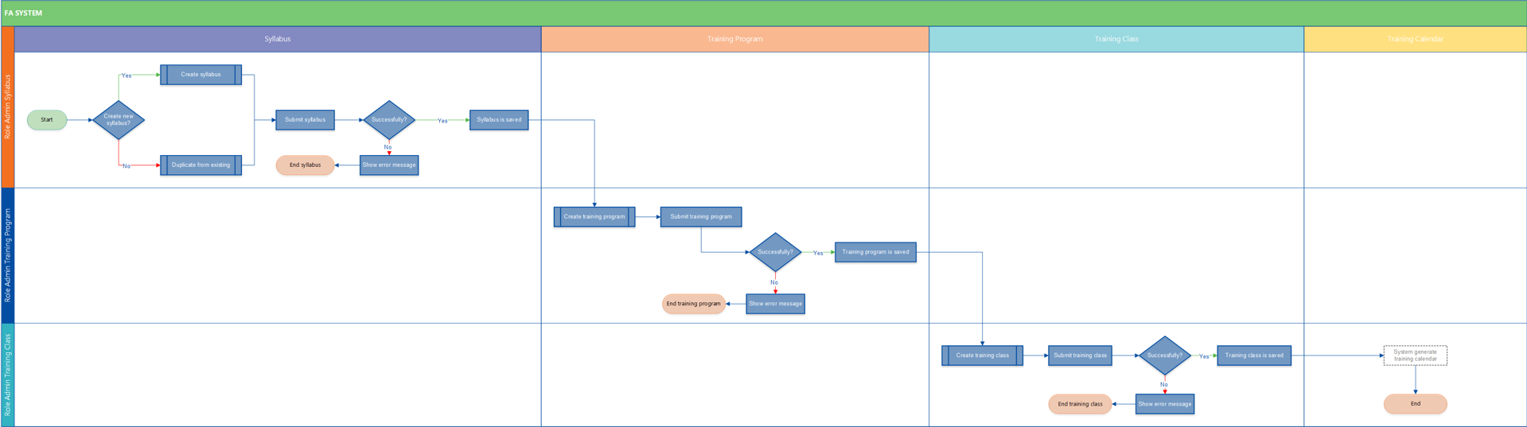

### Flow 1.5_1: User Story 1 + 2

* User Story 1: Create syllabus
* User Story 2: Update syllabus

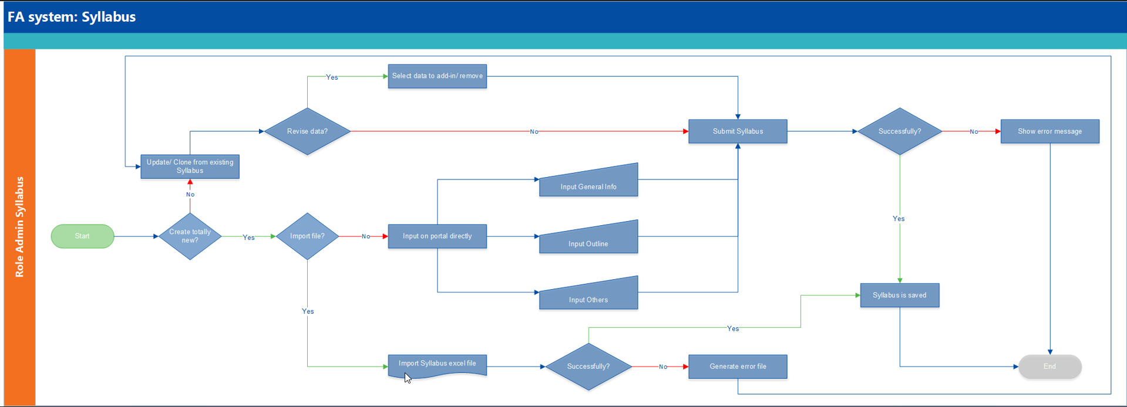

### Flow 1.5_2: User Story 3 + 4

* User Story 3: Create training program
* User Story 4: Update training program

### Flow 1.5_3: User Story 5 + 6

* User Story 5: Create training class
* User Story 6: Update training class

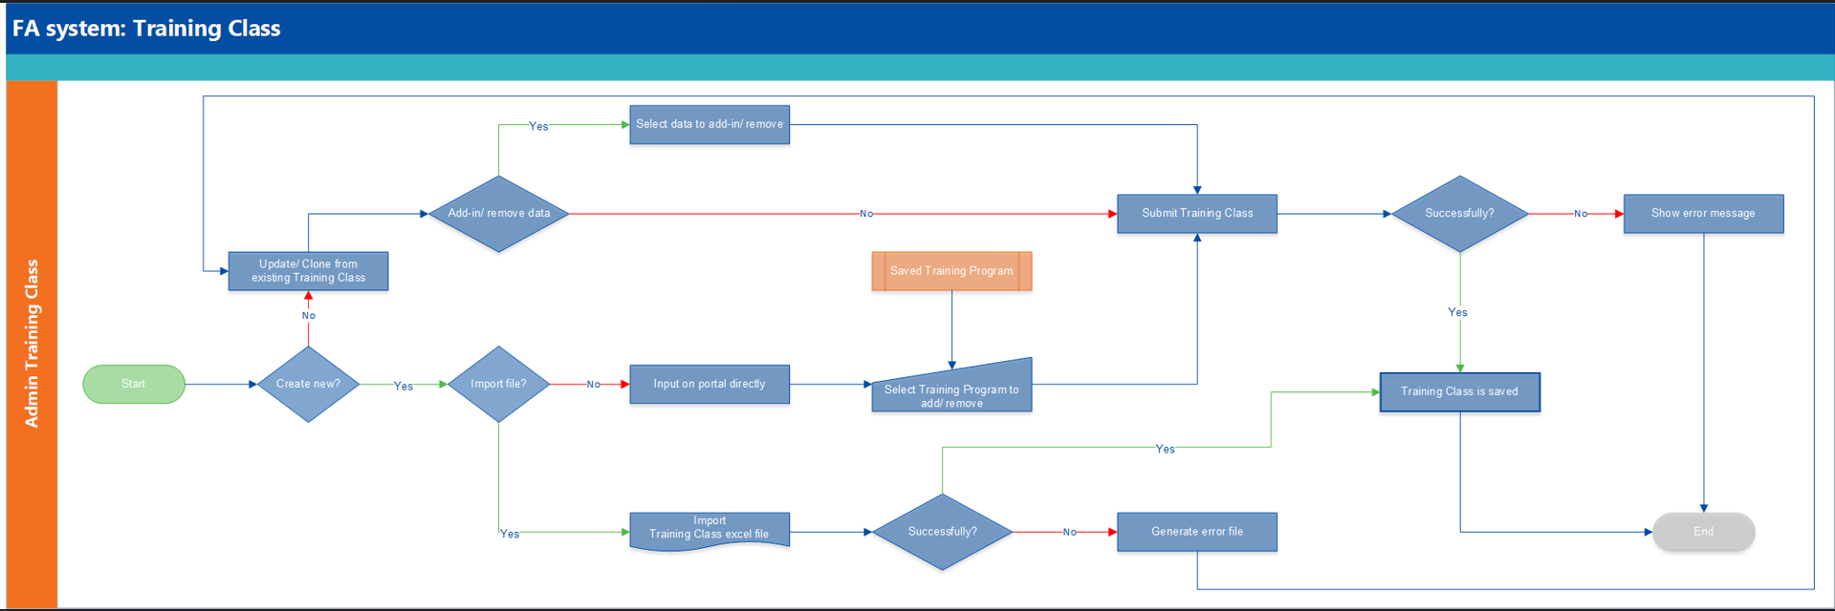

### Flow 1.5_4: User Story 7

* User Story 7: Create/ View training calendar

# 2. Overall Description

## 2.1. Product Perspective

Class planning management application website is used to create a class with detailed program training content in specific duration. With different learners, admin can easily adjust training program content.

## 2.2. Product Functions

|  |  |  |
| --- | --- | --- |
| No. | Feature | Development Scope |
| **Common Function** | | |
| 1 | Upload file function | Upload training material |
| 2 | Create object function | Create includes syllabus, training program, training class |
| 3 | Edit object function | Edit includes syllabus, training program, training class |
| 4 | Delete object function | Delete includes syllabus, training program, training class |
| 5 | Change status of object function | Status of syllabus, training program, training class |
| 6 | Import object function | Import list of syllabuses, training program, training class |
| **Main function** | | |
| 1 | Create syllabus | By specific training topic, users can create detailed training program contents. Syllabus is a master data to create a training program. |
| 2 | Update syllabus | In lists of created syllabuses, users choose the syllabus that they want to update, then users move to screen with detailed information related. Because the syllabus is a master data of training program, be careful to update it, it will affect all programs using it. |
| 3 | Create training program | Training program is created by combining many syllabuses. |
| 4 | Update training program | Allow users to update created training programs. |
| 5 | Create training class | Training program is a meta data to create a training class. Depending on different learners, users can easily edit training content to create a different class. |
| 6 | Update training class | Allow users to update the created training class. |
| 7 | Filter function in calendar | Filter date, time frame, class location, class status |
| 8 | Allocation calculation | Automatically calculate the allocation of the syllabus |
| 9 | Training class code | Automatically generate based on class location, created year, attendee, class name, class number  Format: HCM22_FR.O_DevOps_01  HCM: data from Location field  22: current year of system  FR: data from Program Content column  O: data from Format type column  01: sequence number auto generated from the system from 01 to 99 of 1 course name |

### Table 2.2_1: Function list

## 2.3. User Characteristics

There are mainly four kinds of users is used in this system:

1. **Super admin:** this user has full access on any screen. Admin is responsible for maintaining the system, involved in software fixes, deployment and regular maintenance. Super admin can create a syllabus, training program and class.
2. **Class admin:** this user can view training class to support setup room, equipment for study, check status of trainer, trainees.
3. **Trainer:** this user can create a syllabus, create a training program.
4. **Trainee: this user is the** learner can view the specific training program and download the training material or access to link that added on training material popup to study

## 2.4. Constraints

Following are the main constraints

1. In Screen list of syllabuses, list of training program, user can only view maximum 10,000 rows
2. Upload file size is maximum 40MB.
3. This system is supported on Chrome and Firefox browsers. The other browser may be not perfectly.

# 3. Specific Requirements

## 3.1. Functionality

**Icons in table Item definition:**

|  |
| --- |
| **Type:** Link, Button, Textbox, Textrea, Combobox, Listbox, Label, Radio Button, CheckBox, Table, Password, hidden, Calendar, Tooltip |
| **Attribute:** 9 (Numeric), X (Alphanumeric), － (None) |
| **Display Yes/No:** ○ (Displayed), △ (Displayed with condition), × (Not displayed) |
| **Input Yes/No:** ○ (Can input), △ (Can input with condition), × (Cannot input) |
| **Required:** ○ (Required), △ (Required with condition), × (Not required) |

### Table 3.1_1: Icon meaning in Table Item definition

### 3.1.1. Use Case 1: Login

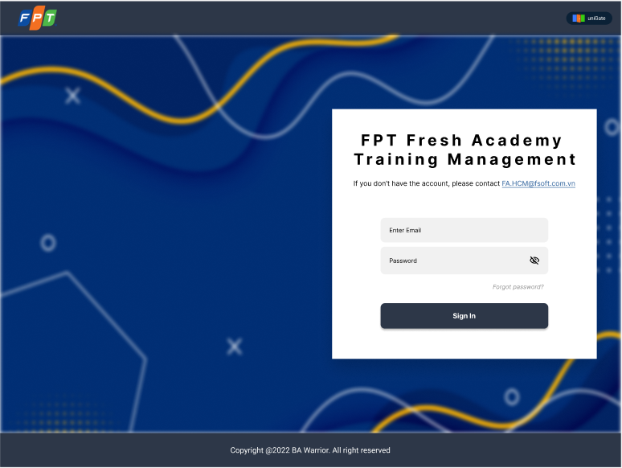

### Figure 3.1.1_1: Login



### Figure 3.1.1_2: EM01

|  |  |  |  |  |  |  |
| --- | --- | --- | --- | --- | --- | --- |
| Screen on web | Platform | Function | As a <type of user> | I want to <perform a task> | So that I can <achieve some goals> | Business rule |
| 1 | Web | Login | End user | Login account to access the application. | Login successfully and the system will direct the user to the home page. | User input incorrect information to log in System shows error messages EM01 “Invalid username or password” or EM02 “Required field!” |
| User input correct information to log in System directs to Homepage. |

### Table 3.1.1_1: User story

|  |  |  |  |  |  |  |  |  |
| --- | --- | --- | --- | --- | --- | --- | --- | --- |
| No | Screen item name | Type | Attribute | Length max | Display  Yes/No | Input  Yes/No | Required | Supplementary explanation |
| 1 | Enter Email | Textbox | X | Max: 40 | ○ | ○ | ○ | Need to have an email domain |
| 2 | Password | Textbox | X | Min: 12 | ○ | ○ | ○ | Hide/Unhide  Password should be password of fsoft account |
| 3 | Sign in | Button | - | - | ○ | x | ○ | [Ev01] [**[Process Flow]**  Step 1: after inserting email address and password, user clicks Login button, system returns error message (failure) or directs user to Homepage (success) -False: Display error msg "Invalid username or password." -True: Direct user to home page |
| 4 | Forgot password? | Link | - | - | ○ | x | ○ | [Ev02] **[Process Flow]**  Step 1: Click Forgot password link, system directs user to the Forgot password page to reset password |
| 5 | If you don’t have an account, please contact  [FA.HCM@fsoft.com.vn](mailto:FA.HCM@fsoft.com.vn) | Label/Link | - | - | ○ | x | ○ | [Ev03] **[Process Flow]**  Step 1: If user has no account, click FA.HCM@fsoft.com.vn link, system will open Outlook to compose a new email  Step 2: user fills in all info and send email to FA.HCM@fsoft.com.vn to create a new account |
| 6 | FPT Fresh Academy  Training Management | Label | - | - | ○ | x | ○ | System name |

### Table 3.1.1_2: Item and event description

### 3.1.2. Use Case 2: List of Syllabus

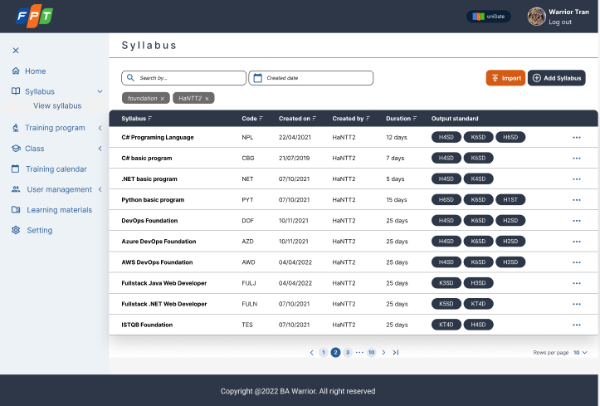

### Figure 3.1.2_1: List of Syllabus

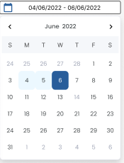

### Figure 3.1.2_2: Date picker calendar

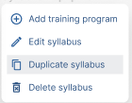

### Figure 3.1.2_3: Syllabus popup menu

|  |  |  |  |  |  |  |
| --- | --- | --- | --- | --- | --- | --- |
| Screen on web | Platform | Function | As a <type of user> | I want to <perform a task> | So that I can <achieve some goals> | Business rule |
| 2 | Web | List of Syllabus | End user | View list of syllabuses | -View all syllabus  -Search syllabus  -Open form Syllabus details  -Open form Create Syllabus | N/A |

### Table 3.1.2_1: User story

|  |  |  |  |  |  |  |  |  |
| --- | --- | --- | --- | --- | --- | --- | --- | --- |
| No | Screen item name | Type | Attribute | Length max | Display  Yes/No | Input  Yes/No | Required | Supplementary explanation |
| 1 | Syllabus | Label | - | - | ○ | x | - | - |
| 2 | Search By | Combobox | X | 30 | ○ | ○ | x | Default value: Search by syllabus name, code, creator & output.  [Ev01] **[Process Flow]**  Step 1: When users input keywords and press Enter, a list of syllabuses according to keywords will be shown. |
| 3 | Keyword | Label | - | - | △ | x | x | Shown under field Search By after user input keywords. |
| 4 | Created Date | Calendar | - | - | ○ | ○ | x | Default value: from today to today + 3 months.  [Ev02] **[Process Flow]**  Step 1: When the user selects the range of time from field Created Date, a list of syllabuses according to range of time will be shown. |
| 5 | Import | Button | - | - | ○ | x | - | [Ev03] **[Process Flow]**  Step 1: On click, the system opens the form Import file. |
| 6 | Add Syllabus | Button | - | - | ○ | x | - | [Ev04] **[Process Flow]**  Step 1: On click, the system directs to screen Create Syllabus. |
| Table List of Syllabus | | | | | | | | |
| 7 | Syllabus | Label/Link | - | - | ○ | x | - | Show name of syllabus.  [Ev05] **[Process Flow]**  Step 1: On click, the system directs to screen Syllabus details of this syllabus.  [Ev06] **[Process Flow]**  Step 1: On right-click, the system prompts the Syllabus popup menu. |
| 8 | Code | Label | - | - | ○ | x | - | Show code of syllabus. |
| 9 | Created on | Label | Format value: dd/mm/yyyy  d: day  m: month  y: year | - | ○ | x | - | Show creation date of syllabus. |
| 10 | Created by | Label | - | - | ○ | x | - | Show the person who created the syllabus. |
| 11 | Duration | Label | Format value: x days  x: total days of syllabus | - | ○ | x | - | Show duration of syllabus. |
| 12 | Output standard | Label | - | - | ○ | x | - | Show output standard code. |
| 13 | Syllabus menu | Icon | - | - | ○ | x | - | [Ev07] **[Process Flow]**  Step 1: On click, the system prompts the Syllabus popup menu. |
| Syllabus popup menu (Figure 5) | | | | | | | | |
| 14 | Add training program | Button | - | - | △ | x | - | [Ev08] **[Process Flow]**  Step 1: On click, the system directs to screen Create Training Program. |
| 15 | Edit syllabus | Button | - | - | △ | x | - | [Ev09] **[Process Flow]**  Step 1: On click, the system directs to screen Edit Syllabus. |
| 16 | Duplicate syllabus | Button | - | - | △ | x | - | [Ev10] **[Process Flow]**  Step 1: On click, the system directs to screen Create Syllabus of new syllabus with same data of this syllabus.  Name of new syllabus: Copy of [Syllabus name] |
| 17 | Delete syllabus | Button | - | - | △ | x | - | Disable or enable buttons based on role permission of the system.  [Ev11] **[Process Flow]**  Step 1: When the button is enabled and the user clicks on the button, the system prompts Confirmation popup. |

### Table 3.1.2_2: Item and event description

### 3.1.3. Use Case 3: Syllabus details

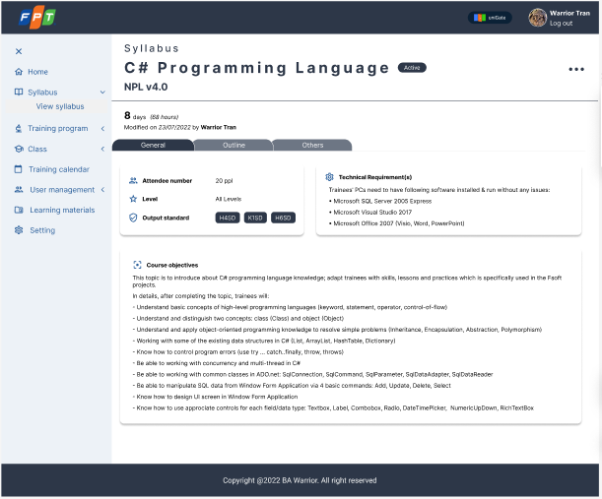

### Figure 3.1.3_1: Syllabus details - tab General

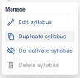

### Figure 3.1.3_2: Syllabus manage popup

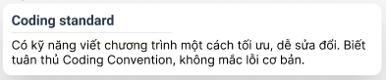

### Figure 3.1.3_3: Output standard tooltip

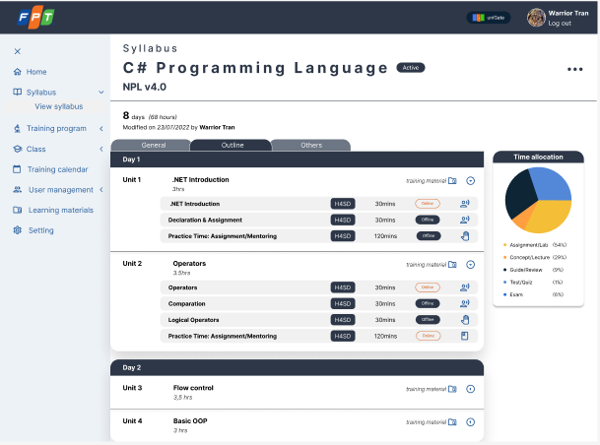

### Figure 3.1.3_4: Syllabus details - tab Outline

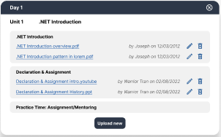

### Figure 3.1.3_5: Training material popup

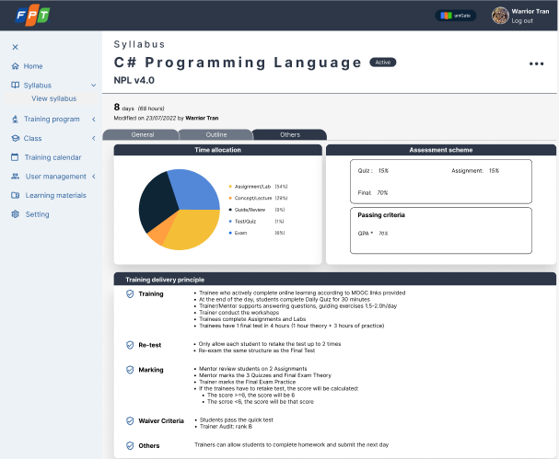

### Figure 3.1.3_6: Syllabus details - tab Others

|  |  |  |  |  |  |  |  |
| --- | --- | --- | --- | --- | --- | --- | --- |
| Screen on web | Platform | Function | As a <type of user> | Role | I want to <perform a task> | So that I can <achieve some goals> | Business rule |
| 3 | Web | Syllabus details | End user | End user | View syllabus details | -Know the content of a specific syllabus | N/A |
|

### Table 3.1.3_1: User story

|  |  |  |  |  |  |  |  |  |  |
| --- | --- | --- | --- | --- | --- | --- | --- | --- | --- |
| No | Screen item name | Type | Attribute | Length max | Arrange | Display  Yes/No | Input  Yes/No | Required | Supplementary explanation |
| 1 | Syllabus | Label | - | - | - | ○ | x | ○ | - |
| 2 | Syllabus name | Label | - | - | - | ○ | x | - | Show name of syllabus. |
| 3 | Syllabus code | Label | - | - | - | ○ | x | . | Show code of syllabus. |
| 4 | Syllabus manage | Icon | - | - | - | ○ | x | - | [Ev01] **[Process Flow]**  Step 1: On click, system prompts Syllabus manage popup. |
| 5 | Duration | Label | Format value: x days (y hours)  x: total days of syllabus  y: total hours of syllabus | - | - | ○ | x | - | Show duration of syllabus. |
| 6 | Modify information | Label | Format value: Modified on dd/mm/yyyy by z  d: day  m: month  y: year  z: person who created syllabus | - | - | ○ | x | - | Show modified information of syllabus. |
| 7 | Syllabus mode | Label | - | - | - | ○ | x | - | Value list: Active, Inactive  Default value: Active  Show mode of syllabus. |
| 8 | Navigation bar | Button | - | - | - | ○ | x | - | Value list: General, Outline, Others.  [Ev02] **[Process Flow]**  Step 1: When the user clicks on a tab, this tab is highlighted and shows corresponding information of the syllabus. |
| Syllabus manage popup (Figure 7) | | | | | | | | | |
| 9 | Manage | Label | - | - | - | △ | x | - | - |
| 10 | Edit syllabus | Button | - | - | - | △ | x | - | [Ev03] **[Process Flow]**  Step 1: On click, the system directs to screen Edit Syllabus. |
| 11 | Duplicate syllabus | Button | - | - | - | △ | x | - | [Ev04] **[Process Flow]**  Step 1: On click, the system directs to screen Create Syllabus of new syllabus with same data of this syllabus.  Name of new syllabus: Copy of [Syllabus name] |
| 12 | De-active syllabus | Button | - | - | - | △ | x | - | [Ev05] **[Process Flow]**  Step 1: On click, Syllabus mode is changed from Active to Inactive. |
| 13 | Delete syllabus | Button | - | - | - | △ | x | - | Disable or enable buttons based on role permission of the system.  [Ev06] **[Process Flow]**  Step 1: When the button is enabled and the user clicks on the button, the system prompts Confirmation popup. |
| Output Standard tooltip (Figure 8) | | | | | | | | | |
| 14 | Title | Label | - | - | - | △ | x | - | Data is retrieved from Master Data. |
| 15 | Content | Label | - | - | - | △ | x | - | Data is retrieved from Master Data. |
| Tab General (Figure 6) | | | | | | | | | |
| 16 | Attendee number | Label | - | - | - | ○ | x | - | - |
| 17 | Level | Label | - | - | - | ○ | x | - | - |
| 18 | Output standard | Label | - | - | - | ○ | x | - | - |
| 19 | Technical Requirement(s) | Label | - | - | - | ○ | x | - | - |
| 20 | Course objectives | Label | - | - | - | ○ | x | - | - |
| Tab Outline (Figure 9) | | | | | | | | | |
| 21 | Time allocation | Chart | Type: pie chart | - | - | ○ | x | - | Value list:  Assignment/Lab  Concept/Lecture  Guide/Review  Test/Quiz  Exam |
| 22 | Day | Label | - | - | - | ○ | x | - | - |
| 23 | Unit | Label | - | - | - | ○ | x | - | - |
| 24 | Unit name | Label | - | - | - | ○ | x | - | - |
| 25 | Lesson name | Label | - | - | - | ○ | x | - | - |
| 26 | Output standard | Label | - | - | - | ○ | x | - | [Ev07] **[Process Flow]**  Step 1: When the user hover mouse on the label, the tooltip will be shown. |
| 27 | Time | Label | Format value: x mins  X: minutes | - | - | ○ | x | - | - |
| 28 | Lesson type | Label | - | - | - | ○ | x | - | Value list: Online, Offline |
| 29 | Delivery types | Icon | - | - | - | O | x | - | [Ev08] **[Process Flow]**  Step 1: When the user hover mouse on the icon, the tooltip will be shown. |
| 30 | Training material | Icon | - | - | - | ○ | x | - | [Ev09] **[Process Flow]**  Step 1: On click, system prompts Training material popup. |
| 31 | Toggle | Icon | - | - | - | ○ | x | - | [Ev10] **[Process Flow]**  Step 1: On click, expand and collapse form. |
| Training material popup (Figure 10) | | | | | | | | | |
| 32 | Day | Label | - | - | - | △ | x | - | - |
| 33 | Unit | Label | - | - | - | △ | x | - | - |
| 34 | Unit name | Label | - | - | - | △ | x | - | - |
| 35 | Close | Icon | - | - | - | △ | x | - | [Ev11] **[Process Flow]**  Step 1: On click, Training material popup will be closed. |
| 36 | Lesson name | Label | - | - | - | △ | x | - | - |
| 37 | File name | Link | File format: excel, ppt, word, picture, link | - | - | △ | x | - | [Ev12] **[Process Flow]**  Step 1: On click,  If you type a link, the system will direct to this link.  Else, files will be downloaded. |
| 38 | Modify Information | Label | Format value: by x on dd/mm/yyyy  x: person who uploaded file.  d: day  m: month  y: year | - | - | △ | x | - | Show modified information.  Updated after user edit training material. |
| 39 | Edit | Icon | - | - | - | △ | x | - | [Ev13] **[Process Flow]**  Step 1: On click, system opens form Open from local system |
| 40 | Delete | Icon | - | - | - | △ | x | - | Delete file name.  [Ev14] **[Process Flow]**  Step 1: On click, system prompts Confirmation popup |
| 41 | Upload new | Button | - | - | - | △ | x | - | [Ev15] **[Process Flow]**  Step 1: On click, system opens form Upload File |
| Tab Others (Figure 11) | | | | | | | | | |
| 42 | Time allocation | Chart | Type: pie chart | - | - | ○ | x | - | Value list:  Assignment/Lab  Concept/Lecture  Guide/Review  Test/Quiz  Exam |
| 43 | Assessment scheme | Label | - | - | - | ○ | x | - | - |
| 44 | Quiz | Label | - | - | - | ○ | x | - | - |
| 45 | Assignment | Label | - | - | - | ○ | x | - | - |
| 46 | Final | Label | - | - | - | ○ | x | - | - |
| 47 | Passing criteria | Label | - | - | - | ○ | x | - | - |
| 48 | GPA | Label | - | - | - | ○ | x | - | - |
| 49 | Training delivery principle | Label | - | - | - | ○ | x | - | - |
| 50 | Training | Label | - | - | - | ○ | x | - | - |
| 51 | Re-test | Label | - | - | - | ○ | x | - | - |
| 52 | Marking | Label | - | - | - | ○ | x | - | - |
| 53 | Waiver Criteria | Label | - | - | - | ○ | x | - | - |
| 54 | Others | Label | - | - | - | ○ | x | - | - |

### Table 3.1.3_2: Item and event description

### 3.1.4. Use Case 4: Create New Syllabus

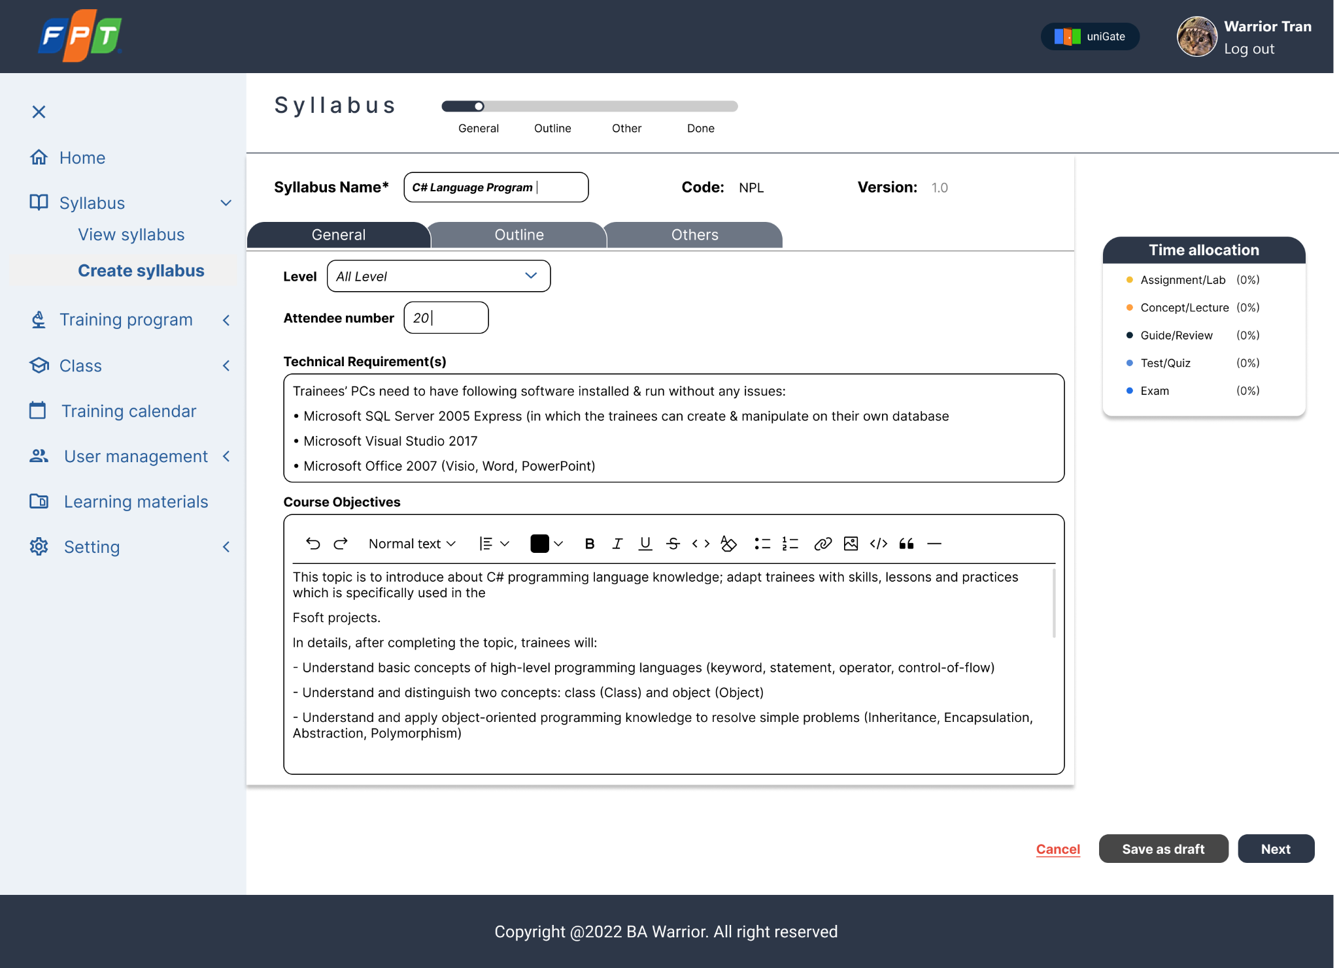

### Figure 3.1.4_1: Create Syllabus - tab General



### Figure 3.1.4_2: Create Syllabus - tab Outline

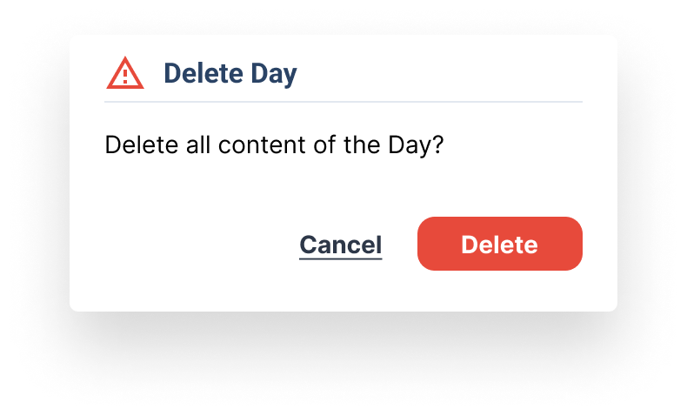

### Figure 3.1.4_3: Create Syllabus - Delete day popup

### Figure 3.1.4_4: Delivery Type

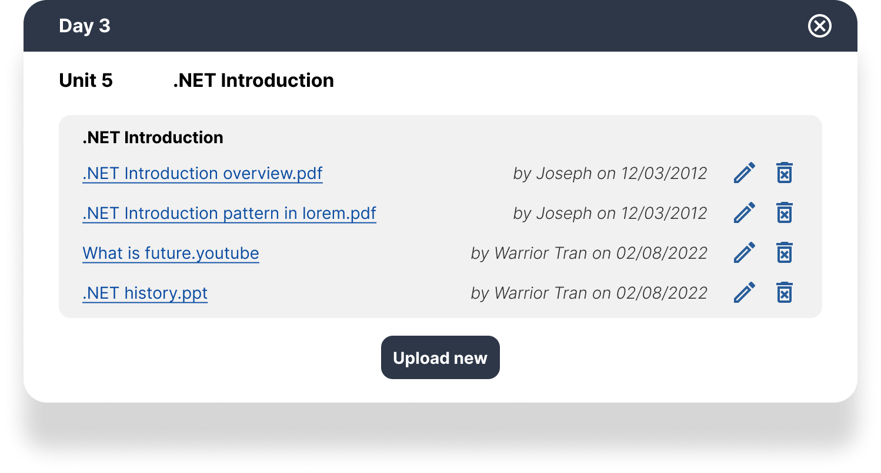

### Figure 3.1.4_5: Training Material

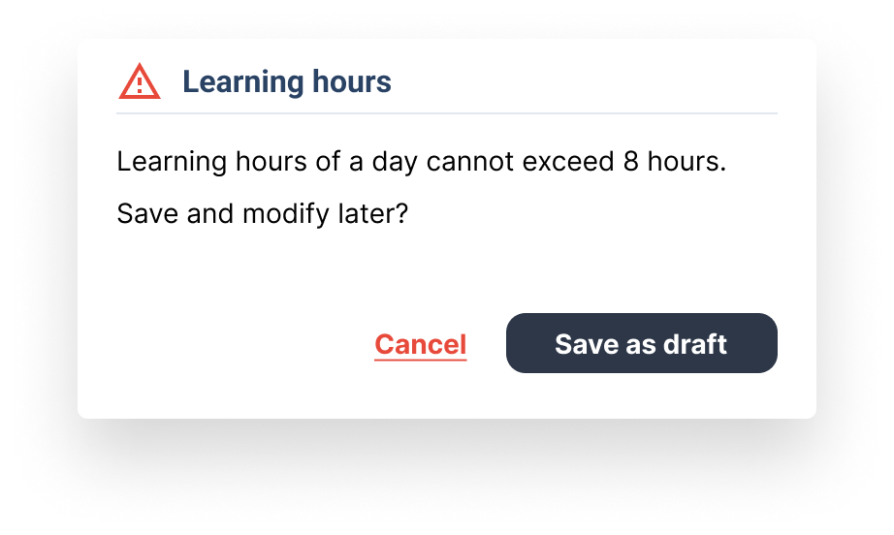

### Figure 3.1.4_6: Alert popup

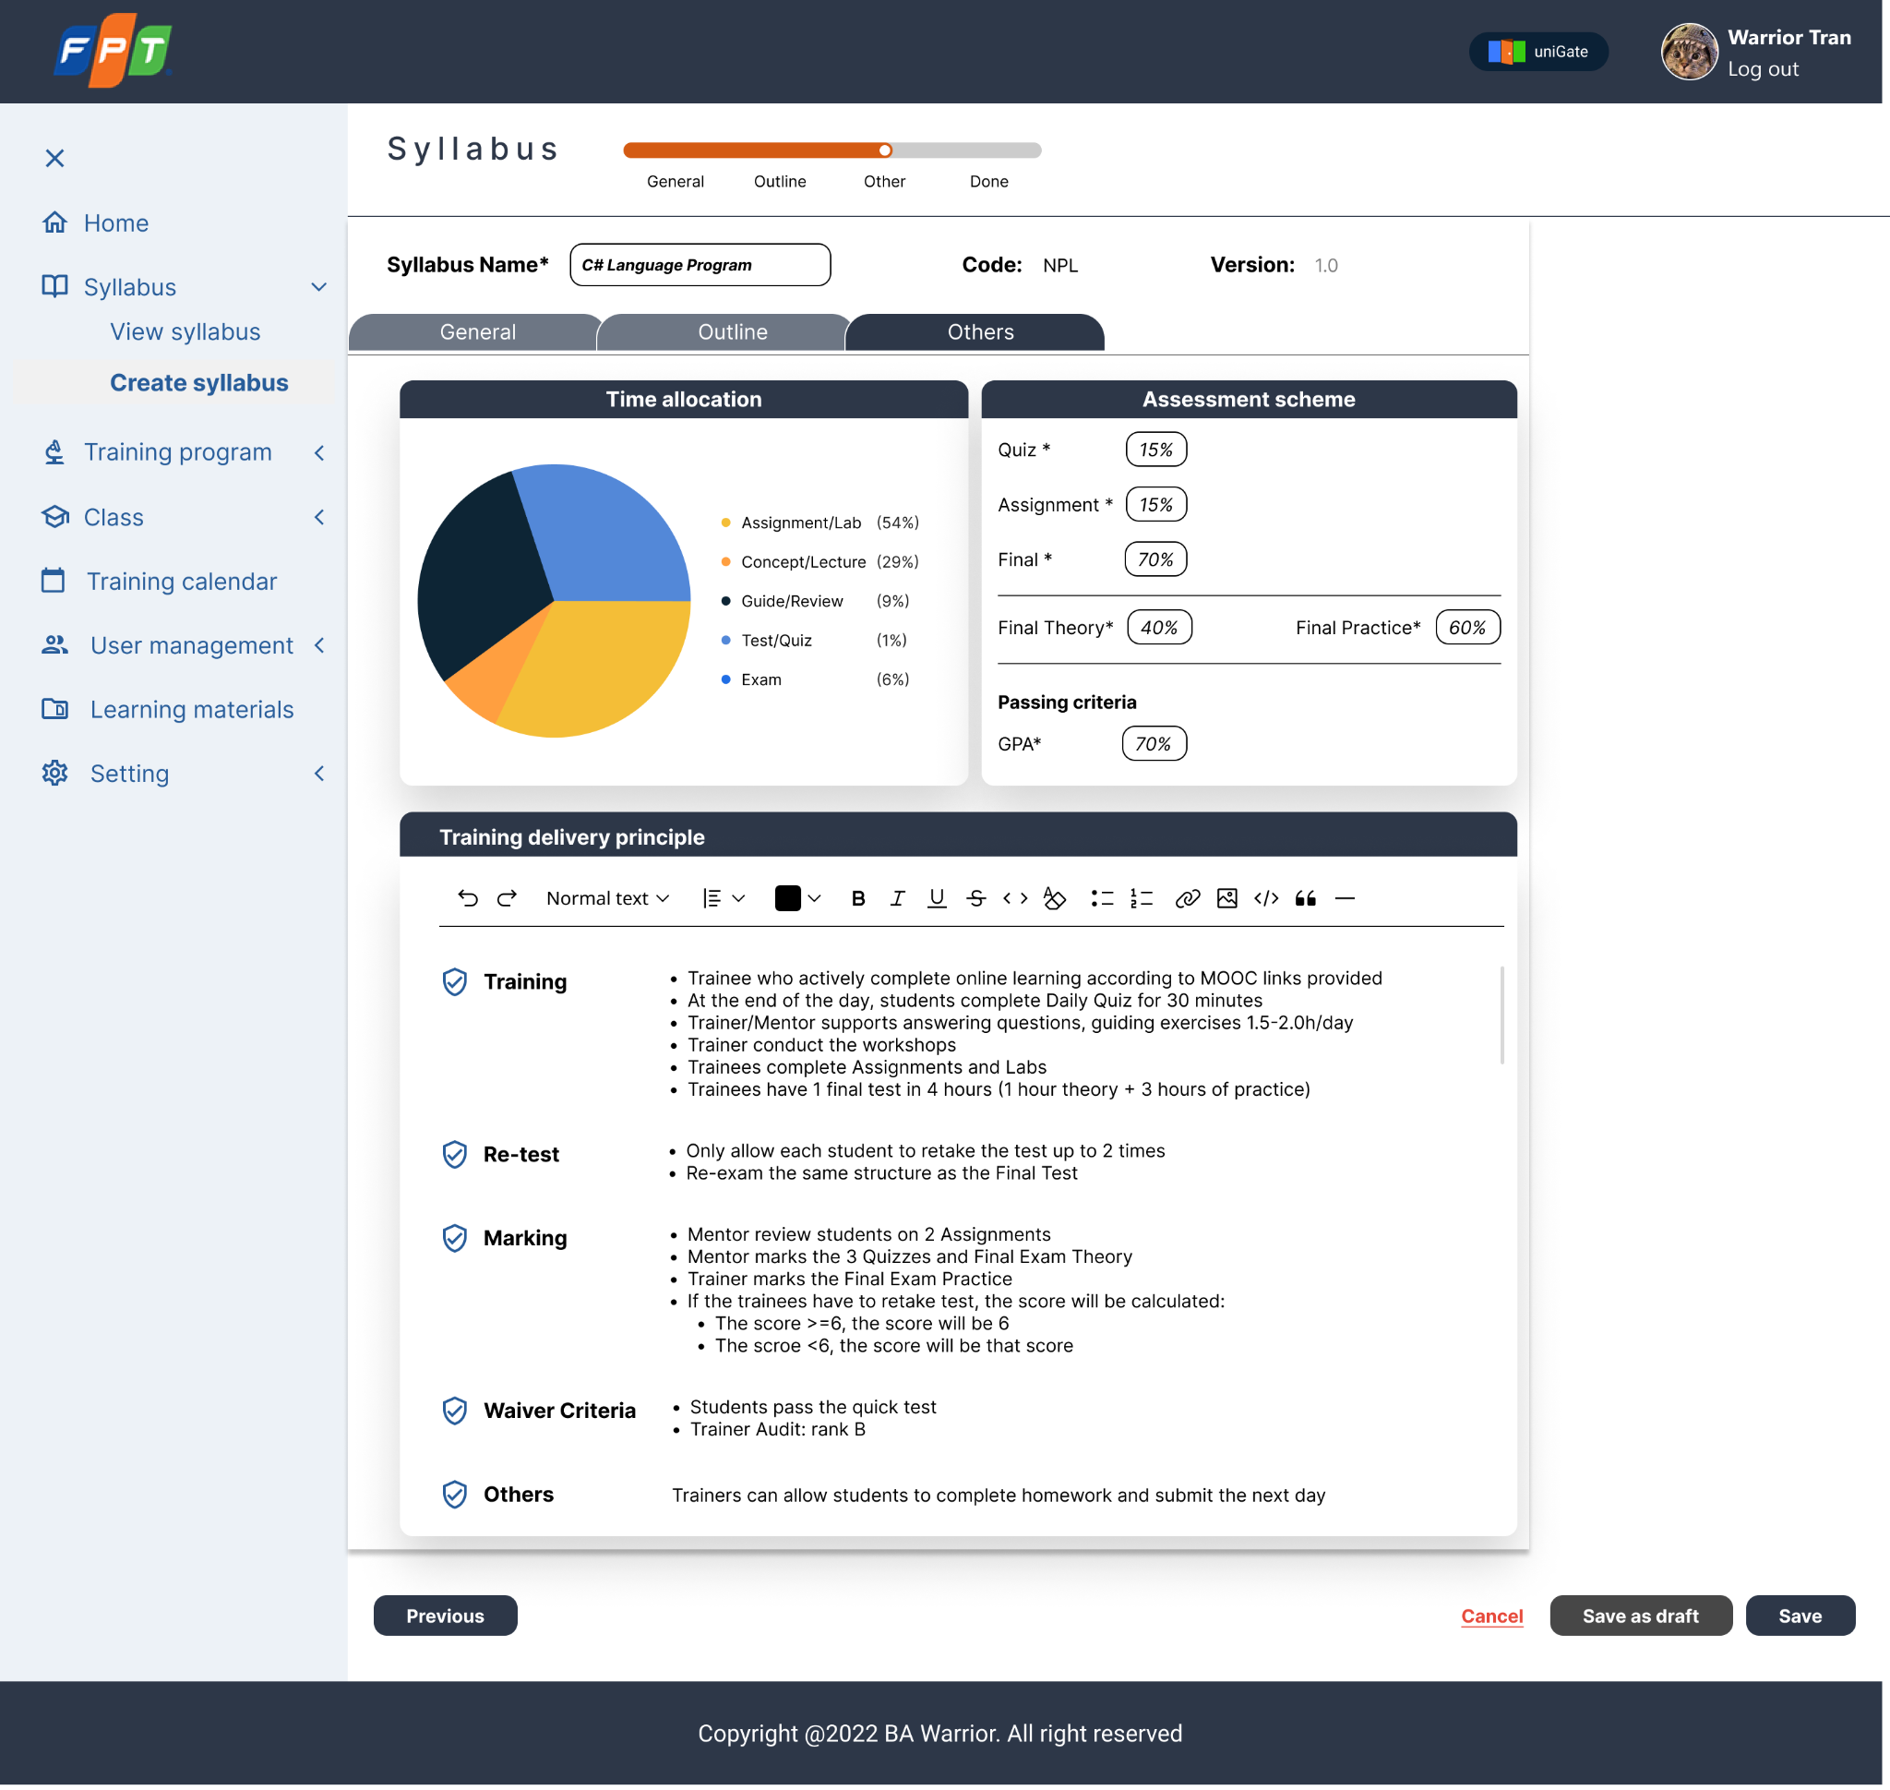

### Figure 3.1.4_7: Create Syllabus - tab Others

|  |  |  |  |  |  |  |
| --- | --- | --- | --- | --- | --- | --- |
| Screen on web | Platform | Function | As a <type of user> | I want to <perform a task> | So that I can <achieve some goals> | Business rule |
| 4 | Web | Create Syllabus | End user | Create New Syllabus | Create a new Syllabus. | -Define Outputs for syllabus.  -Define Assessment scheme for syllabus.  -Add Training Materials for each created syllabus |
|

### Table 3.1.4_1: User story

|  |  |  |  |  |  |  |  |  |
| --- | --- | --- | --- | --- | --- | --- | --- | --- |
| No | Screen item name | Type | Attribute | Length max | Display  Yes/No | Input  Yes/No | Required | Supplementary explanation |
| Create Syllabus (Figure 3.1.4_1) | | | | | | | | |
| 1 | Syllabus | Label | - | - | o | x | x | Display the Module name: “Syllabus” |
| 2 | Progress Status | Table | - | - | o | x | x | Show the input progress:  - The black bar represents that user is inputting General Information.  - The blue bar represents that the user is inputting outline information.  - The orange bar represents that user is inputting others information.  - The green bar represents the Done status.  - The gray bar represents the Not Yet status. |
| 3 | Syllabus Name | Textbox | x | - | o | o | o | Display Syllabus Name [Ev01] **[Process flow]** Step 1: If the user does not fill in the blank, the border will turn red if left blank.  Step 2: User fills in information to the blank. |
| 4 | Syllabus Code | Textbox | x | - | o | x | x | Automatically created with the Syllabus Name. |
| 5 | Syllabus Version | Textbox | x | - | o | o | o | Automatically created with “1.0”  [Ev01] **[Process flow]** Step 1: If the user does not fill in the blank, the border will turn red if left blank.  Step 2: User fills in information to the blank. |
| 6 | Time Allocation | Table | - | - | o | x | x | Default value:  - Assignment/Lab  - Concept/Lecture  - Guide/Review  - Test/Quiz  - Exam  Time Allocation is automatically calculated based on the Syllabus Outline data. Training Delivery Principle is uploaded from the same Principle for all Syllabuses. |
| 7 | Navigation Bar | Button | - | - | △ | x | x | Only when all the required fields are populated will the user move to the next tab. [Ev02] **[Process flow]** Step 1: User clicks the tab and wants to see information on the navigation bar.  Step 2: Highlight tab information. [Ev03] **[Process flow]** Step 1: User clicks the tab and wants to see information on the navigation bar.  Step 2: Display all the information in the Syllabus tab. |
| General(Figure 3.1.4_1) | | | | | | | | |
| 8 | Level | Drop Down-list | - | - | o | o | o | Click to select level |
| 9 | Attendee Number | Textbox | x | - | o | o | o | [Ev01] **[Process flow]** Step 1: If the user does not fill in the blank, the border will turn red if left blank.  Step 2: User fills in information to the blank. |
| 10 | Technical Requirement(s) | Text area | x | Max | o | o | o | [Ev01] **[Process flow]** Step 1: If the user does not fill in the blank, the border will turn red if left blank.  Step 2: User fills in information to the blank. |
| 11 | Course Objectives | Text area | x | Max | o | o | o | [Ev01] **[Process flow]** Step 1: If the user does not fill in the blank, the border will turn red if left blank.  Step 2: User fills in information to the blank. |
| Outline(Figure 3.1.4_2) | | | | | | | | |
| 12 | Day | Label | - | - | o | x | x | Display Day information |
| 13 | Unit | Label | - | - | o | x | x | Display unit information |
| 14 | Unit Name | Label | - | - | o | x | x | Display unit name information |
| 15 | Content Name | Label | - | - | o | x | x | Display lesson name information |
| 16 | Content Type | Button | - | - | o | x | x | Value list: Online, Offline  [Ev04] **[Process flow]** Step 1: If the user wants to switch status, click the button online/offline.  Step 2: The status will automatically switch Online or Offline. |
| 17 | Output standard | Drop Down-list | - | - | o | x | x | Click to select output standard |
| 18 | Unit Duration | Textbox | Format value: x mins  X: minutes | - | o | x | x | Display Unit Duration |
| 20 | Delivery Type | Drop Down-list | - | - | o | o | o | Click to select delivery type. There are 6 types:  - Assignment/ Task  - Concept/ Lecture  - Guide/ Review  - Test/ Quiz  - Exam  - Seminar/ Workshop |
| 21 | Training Material | Button | - | - | o | x | x | [Ev05] **[Process flow]**  Step 1: When the user clicks on the training material icon, the information will be displayed corresponding to the unit.  Step 2: Display Training Material Information related to the unit. |
| 22 | Add Content | Button | - | - | △ | o | x | Active when one content has been entered with all information [Ev06] **[Process flow]** Step 1:Users want to add more content in the unit, click on the Add Content icon.  Step 2: The system will display a new input row with the required fields:  - Content name  - Output - Duration - Delivery Type - Online/Offline |
| 23 | Content | Table | - | - | △ | o | o | Default value: - Content name: "Content Name" - Output: as the adjacent content above - Duration: as the adjacent content above - Delivery Type: as the adjacent content above - Online/Offline: as the adjacent content above [Ev01] **[Process flow]** Step 1: If the user does not fill in the blank, the border will turn red if left blank.  Step 2: User update information to create content. |
| 24 | Add Unit | Button | - | - | △ | o | x | [Ev07] **[Process flow]**  Step 1:Users want to add more units in the day, click on the Add Unit icon.  Step 2: The system will display the fields that need to be input. |
| 25 | Add Day | Button | - | - | △ | o | x | [Ev08] **[Process flow]**  Step 1:Users want to add Day, click on the Add Day icon.  Step 2: The system will display the fields that need to be input. |
| 26 | Upload training material | Table | - | - | o | x | x | [Ev09] **[Process Flow]**  Step 1: On click, system prompts Training material popup. |
| 13 | Collapse button | Button | - | - | o | x | x | [Ev10] **[Process flow]** Step 1: User clicks on the "Collapse" icon.  Step 2: The content of that day/chapter/post will be collapsed by the corresponding level. |
| Others(Figure 3.1.4_7) | | | | | | | | |
| 27 | Assessment schema | Label | - | - | o | x | x | Display the text: “Assessment Schema” |
| 28 | Quiz | Textbox | x | - | o | o | o | [Ev01] **[Process flow]** Step 1: If the user does not fill in the blank, the border will turn red if left blank.  Step 2: User fills in information to the blank. |
| 29 | Assignment | Textbox | x | - | o | o | o | [Ev01] **[Process flow]** Step 1: If the user does not fill in the blank, the border will turn red if left blank.  Step 2: User fills in information to the blank. |
| 30 | Final | Textbox | x | - | o | o | o | [Ev01] **[Process flow]** Step 1: If the user does not fill in the blank, the border will turn red if left blank.  Step 2: User fills in information to the blank. |
| 31 | Final Theory | Textbox | x | - | o | o | o | [Ev01] **[Process flow]** Step 1: If the user does not fill in the blank, the border will turn red if left blank.  Step 2: User fills in information to the blank. |
| 32 | Final Practice | Textbox | x | - | o | o | o | [Ev01] **[Process flow]** Step 1: If the user does not fill in the blank, the border will turn red if left blank.  Step 2: User fills in information to the blank. |
| 33 | Passing criteria | Label | - | - | o | x | x | Display the text: “Passing criteria” |
| 34 | GPA | Textbox | x | - | o | o | o | [Ev01] **[Process flow]** Step 1: If the user does not fill in the blank, the border will turn red if left blank.  Step 2: User fills in information to the blank. |
| 35 | Training delivery principle | Textbox | x | - | o | o | o | [Ev01] **[Process flow]** Step 1: If the user does not fill in the blank, the border will turn red if left blank.  Step 2: User fills in information to the blank. |
| 36 | Action Buttons | Button | - | - | △ | x | x | Create button is only displayed when all the necessary information has been entered. [Ev11] **[Process flow]** Step 1:When the user wants to cancel, click on the Cancel button.  Step 2: The system will navigate the user to the Syllabus Screen. [Ev12] **[Process flow]** Step 1:When the user wants to Save file as Draft, click on Save as Draft button.  Step 2: The system will save all the current information as draft and only the creator can view. [Ev13] **[Process flow]** Step 1:When the user wants to finish creating the syllabus, click on the Done button.  Step 2: Syllabus status will switch to Done. |
| Training Material (Figure 3.1.4_5) | | | | | | | | |
| 37 | Day | Label | - | - | △ | x | - | Display Day information |
| 38 | Unit | Label | - | - | △ | x | - | Display Unit information |
| 39 | Unit name | Label | - | - | △ | x | - | Display Unit Name |
| 40 | Close | Icon | - |  | △ | x | - | [Ev14] **[Process Flow]**  Step 1: When the user wants to close training material popup, click on Close icon.  Step 2: Training material popup will be closed. |
| 41 | Lesson name | Label | - | - | △ | x | - | Display Lesson name information |
| 42 | File name | Link | File format: excel, ppt, word, picture, link | - | △ | x | - | [Ev15] **[Process Flow]**  Step 1: On click,  If you type a link, the system will direct to this link.  Else, files will be downloaded. |
| 43 | Modify Information | Label | Format value: by x on dd/mm/yyyy  x: person who uploaded file.  d: day  m: month  y: year | - | △ | x | - | Show modified information.  Updated after user edit training material. |
| 44 | Edit | Icon | - | - | △ | x | - | [Ev16] **[Process flow]** Step 1: When the user wants to edit the document, click on the pencil icon.  Step 2: The system will allow the user to edit documents. |
| 45 | Delete | Icon | - | - | △ | x | - | [Ev17] **[Process flow]**  Step1: When the user wants to delete a file, click on the trash bin icon.  Step 2: The system will delete uploaded files. |
| 46 | Upload new | Button | - | - | △ | x | - | [Ev18] **[Process Flow]**  Step 1: When the user wants to upload new training material, click on Upload New.  Step 2: The system opens from the Upload File. |
| Delivery Type popup (Figure 3.1.4_6) | | | | | | | | |
| 47 | Assignment/ Task | Label | - | - | o | x | x | Display the text: “Assignment/ Task” |
| 48 | Concept/ Lecture | Label | - | - | o | x | x | Display the text: “Concept/ Lecture” |
| 49 | Guide/ Review | Label | - | - | o | x | x | Display the text: “Guide/ Review” |
| 50 | Test/ Quiz | Label | - | - | o | x | x | Display the text: “Test/ Quiz” |
| 51 | Exam | Label | x | - | o | x | x | Display the text: “Exam” |
| 52 | Seminar/ Workshop | Label | x | - | o | x | x | Display the text: “Seminar/ Workshop” |

### Table 3.1.4_2: Item and event description

### 3.1.5. Use case 5: List of Training Program

### Figure 3.1.5_1: List of Training Program

### Figure 3.1.5_2: Pop-up functions

### Figure 3.1.5_3: List of Training Program (filtered)

|  |  |  |  |  |  |  |
| --- | --- | --- | --- | --- | --- | --- |
| Screen on web | Platform | Function | As a <type of user> | I want to <perform a task> | So that I can <achieve some goals> | Business rule |
| 5 | Web | View training program list | -System Admin -Admin Lead  -Delivery Manager  -Trainer | View Training Program List | View all Training Programs  Search for training Program  View details of a single training program  Open training program creation form | N/A |

### Table 3.1.5_1: User story

|  |  |  |  |  |  |  |  |  |  |
| --- | --- | --- | --- | --- | --- | --- | --- | --- | --- |
| No | Screen item name | Type | Attribute | Length max | Arrange | Display Yes/No | Input Yes/No | Required | Supplementary explanation |
| 1 | Training Program | Label | X | - | - | ○ | × |  | Training Program screen |
| 2 | Search box | Combobox | X | - | - | ○ | ○ | × | [Ev01] **[Process Flow]**  Step 1: Search training program by keyword |
| 3 | Filter | Button | X | - | - | ○ | ○ | × | [Ev02] **[Process Flow]**  Step 1: Filter training program |
| 4 | Import | Button | X | - | - | △ | △ | × | [Ev03] **[Process Flow]**  Step 1: Import training program The template and file type has been defined |
| 5 | Add new | Button | X | - | - | △ | △ | × | [Ev04] **[Process Flow]**  Step 1: Create new training program |
| 6 | ID | Label | X | - | - | ○ | × | × | Training Program ID will be auto generated when creating new one |
| 7 | Program name | Label | X | - | - | ○ | × | × | [Ev05] **[Process Flow]**  Step 1: Click on field name can see the detailed training program |
| 8 | Created on | Calendar | Format: dd/mm/yyy | - | - | ○ | × | × | This field displays Created Time |
| 9 | Created by | Label | X | - | - | ○ | × | × | This field displays Created user |
| 10 | Duration | Label | X | - | - | ○ | × | × | The duration of training program |
| 11 | Status | Label | X | - | - | ○ | × | × | The status of the training program. There are 2 values: active and inactive. Active by default. |
| 12 | Sort | Button | - | - | - | ○ | ○ | × | [Ev06] **[Process Flow]**  Step 1: Sorting |
| 13 | More | Button | - | - | - | ○ | ○ | × | [Ev07] **[Process Flow]**  Step 1: Show more features to modify training program |
| 14 | Page number | Button | - | - | - | △ | ○ | × | Paging of training program screen |
| 15 | < | Button | - | - | - | △ | ○ | × | [Ev08] **[Process Flow]**  Step 1: Back to the previous page Only show when there is more than 1 page and the User is not at 1st page |
| 16 | > | Button | - | - | - | △ | ○ | × | [Ev09] **[Process Flow]**  Step 1: Go to the next page Only show when there is more than 1 page and the User is not at the final page |
| 17 | >|| | Button | - | - | - | △ | ○ | × | [Ev10] **[Process Flow]**  Step 1: Go to the final page |
| 18 | Rows per page | Button | - | - | - | ○ | ○ | × | [Ev11] **[Process Flow]**  Step 1: Change number of Training Program in a screen |
| 19 | searching Tag | Button | - | - | - | △ | ○ | × | [Ev12] **[Process Flow]**  Step 1: Delete the tag |
| 20 | Training material | Button | - | - | - | △ | ○ | × | [Ev13] **[Process Flow]**  Step 1: Open Training Material popup |
| 21 | Edit program | Button | - | - | - | △ | ○ | × | [Ev14] **[Process Flow]**  Step 1: Edit training program Base on User's permission |
| 22 | Duplicate program | Button | - | - | - | △ | ○ | × | [Ev15] **[Process Flow]**  Step 1: Duplicate training program Base on User's permission |
| 23 | De-active program/Active program | Button | - | - | - | △ | ○ | × | [Ev16] **[Process Flow]**  Step 1: Change status of training program Base on User's permission |
| 24 | List of training program | Label | X | - | - | △ | ○ | × | Show all training program or show records corresponding to search tag |

### Table 3.1.5_2: Item and event description

### 

### 3.1.6. Use Case 6: Training Program Details

### 

### Figure 3.1.6_1: Training Program Detail

### Figure 3.1.6_2: Manage Training Program

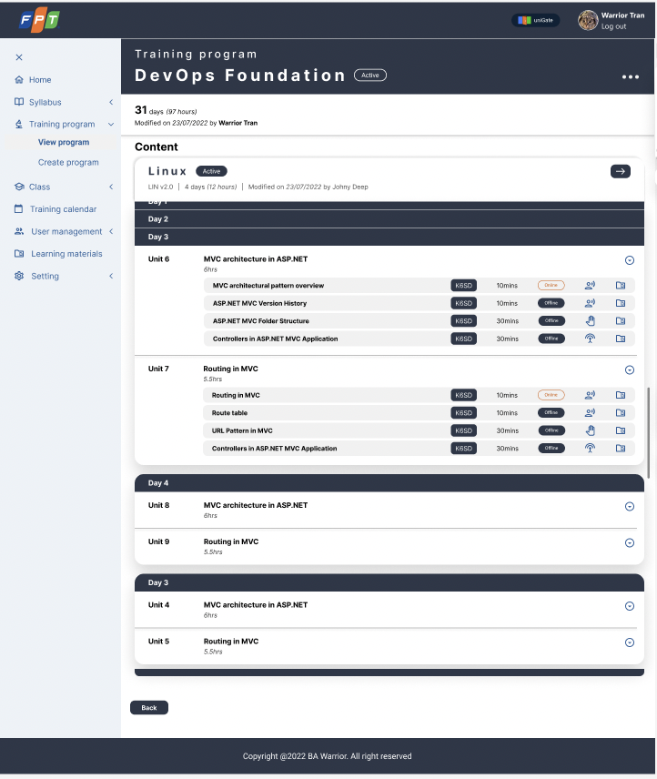

### Figure 3.1.6_3: Syllabus Detail

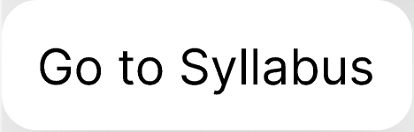

### Figure 3.1.6_4: Go to Syllabus button

### Figure 3.1.6_5: Output Standard

### Figure 3.1.6_6: Tooltips for Delivery Type

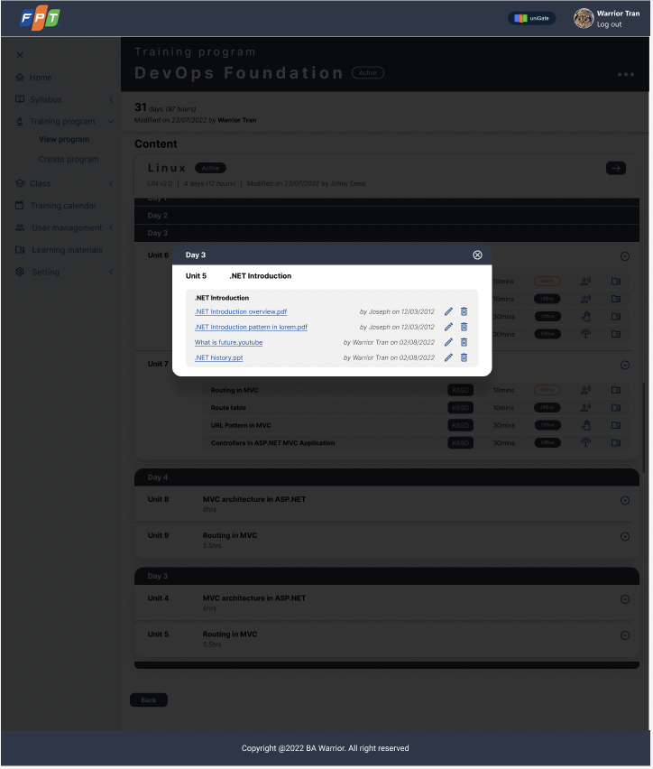

### Figure 3.1.6_7: Training Material popup

|  |  |  |  |  |  |  |
| --- | --- | --- | --- | --- | --- | --- |
| Screen on web | Platform | Function | As a <type of user> | I want to <perform a task> | So that I can <achieve some goals> | Business rule |
| 6 | Web | View Training Program Detail | End user | View details of a Training Program | - View Detailed Information of a Training Program  - View and download Training Materials of a Training Program  - Know the syllabus content of a Training Program  - View details of the included Syllabus | N/A |
|

### Table 3.1.6_1: User story

|  |  |  |  |  |  |  |  |  |  |
| --- | --- | --- | --- | --- | --- | --- | --- | --- | --- |
| No | Screen item name | Type | Attribute | Length max | Arrange | Display  Yes/No | Input  Yes/No | Required | Supplementary explanation |
| Figure 3.1.6.1: Training Program Detail | | | | | | | | | |
| 1 | Training program name | Label | X | - | - | ○ | × | ○ | Name of training program |
| 2 | More icon | Button | - | - | - | ○ | ○ | × | More options |
| 3 | "Active/Inactive" field | Label | X | - | - | ○ | × | ○ | The status of the training program. |
| 4 | "31" in days field | Label | 9 | - | - | △ | × | × | Total duration of training program in days |
| 5 | "97" in hours field | Label | 9 | - | - | △ | × | × | Total duration of training program in hours |
| 6 | "Modified on 23/07/2022" field | Calendar | Format: dd/mm/yyyy | - | - | △ | × | × | The latest modified date of training Program |
| 7 | "By Warrior Tran" field | Label | X | - | - | ○ | × | ○ | The user who modified the training program |
| 8 | Syllabus name | Label | X | - | - | △ | × | × | The name of the syllabus. Automatically show syllabus corresponding |
| 9 | "Active/Inactive" field | Label | X | - | - | △ | × | × | The status of the syllabus |
| 10 | "LIN v2.0" field | Label | X | - | - | △ | × | × | The code and version of each syllabus |
| 11 | "4" in days field | Label | 9 | - | - | △ | × | × | Time duration of each syllabus in days |
| 12 | "12" in hours field | Label | 9 | - | - | △ | × | × | Time duration of each syllabus in hours |
| 13 | "Modified on 23/07/2022" field | Calendar | Format: dd/mm/yyyy | - | - | △ | × | × | The latest modified date of each syllabus |
| 14 | "by Johny Deep" field | Label | X | - | - | △ | × | × | The user who modified each syllabus |
| Figure 3.1.6.2: Manage Training Program | | | | | | | | | |
| 15 | Training Material button | Button | - | - | - | △ | ○ | × | [Ev01] **[Process Flow]**  Step 1: System shows the Training Material popup |
| 16 | Edit training program button | Button | - | - | - | △ | ○ | × | [Ev02] **[Process Flow]**  Step 1: Show modifying options base on the permission of User |
| 17 | Duplicate training program button | Button | - | - | - | △ | ○ | × | [Ev03] **[Process Flow]**  Step 1: The system makes a copy of <training program name>  Step 2: Go to "Edit Training Program" screen |
| 18 | De-activate/Activate training program button | Button | - | - | - | △ | ○ | × | [Ev04] **[Process Flow]**  Step 1: The system changes the status of the selected program from "Active" to "Inactive" or "Inactive" to "Active" |
| Figure 3.1.6.3: Syllabus Detail | | | | | | | | | |
| 19 | Training program name | Label | X | - | - | ○ | × | ○ | Name of training program |
| 20 | "Active/Inactive" field | Label | X | - | - | ○ | × | ○ | The status of the training program. |
| 21 | "31" in days field | Label | 9 | - | - | △ | × | × | Total duration of training program in days |
| 22 | "97" in hours field | Label | 9 | - | - | △ | × | × | Total duration of training program in hours |
| 23 | "Modified on 23/07/2022" field | Calendar | Format: dd/mm/yyyy | - | - | △ | × | × | The latest modified date of training Program |
| 24 | "By Warrior Tran" field | Label | X | - | - | ○ | × | ○ | The user who modified the training program |
| 25 | Syllabus name | Label | X | - | - | △ | × | × | The name of the syllabus. Automatically show syllabus corresponding |
| 26 | "Active/Inactive" field | Label | X | - | - | △ | × | × | The status of the syllabus |
| 27 | "LIN v2.0" field | Label | X | - | - | △ | × | × | The code and version of the syllabus |
| 28 | "4" in days field | Label | 9 | - | - | △ | × | × | Time duration of the syllabus in days |
| 29 | "12" in hours field | Label | - | - | - | △ | × | × | Time duration of the syllabus in hours |
| 30 | "Modified on 23/07/2022" field | Calendar | Format: dd/mm/yyyy | - | - | △ | × | × | The latest modified date of the syllabus |
| 31 | "by Johny Deep" field | Label | X | - | - | △ | × | × | The user who modified the syllabus |
| 32 | Arrow button | Button | - | - | - | △ | ○ | × | [Ev05] **[Process Flow]**  Step 1: Go to Syllabus Detail Screen [Figure 3.1.6.4: Go to Syllabus button]. The system shows the Syllabus Detail Screen of the current syllabus |
| 33 | Day | Label | X | - | - | △ | × | × | Ascending by default |
| 34 | Collapse button | Button | - | - | - | △ | ○ | × | [Ev06] **[Process Flow]**  Collapse the content of unit  At the Unit which button User clicks  Step 1: Hide item 36 to 43  Step 2: Item 34 is switched to item 35 |
| 35 | Extend button | Button | - | - | - | △ | ○ | × | [Ev07] **[Process Flow]**  At the Unit which button User clicks  Step 1: Show item 36 to 43  Step 2: Item 35 is switched to item 34 |
| 36 | Unit | Label | - | - | - | △ | × | × | The order number of unit in a training program, ascending by default |
| 37 | Unit Name | Label | - | - | - | △ | × | × | The name of unit |
| 38 | Unit hours | Label | - | - | - | △ | × | × | Time duration of the unit in hours |
| 39 | Output standard | Label | - | - | - | △ | × | × | [Ev08] **[Process Flow]**  Step 1: Use hover at item 39  Step 2: The system shows corresponding item 40 |
| 40 | Output standard popup | Textarea | - | - | - | △ | × | ○ | Show the detail of output standing [Figure: 3.1.6.5: Output Standard] |
| 41 | Specific unit duration | Label | - | - | - | △ | × | × | The duration of each topic in a unit |
| 42 | Delivery type icon |  | - | - | - | △ | × | × | Delivery type of unit [Figure 3.1.6.6: Tooltip for Delivery Types] |
| 43 | "Training material" button | Button | - | - | - | △ | ○ | × | [Ev09] **[Process Flow]**  Step 1: The system shows the Training material popup at the center of the screen and clay background in the back |
| 44 | Back button | Button | - | - | - | ○ | ○ | × | [Ev10] **[Process Flow]**  Step 1: Go back to the previous screen. The system shows the Training Program details screen |
| Figure 3.1.6.7: Training Material Popup | | | | | | | | | |
| 45 | Material name | Link | - | - | - | △ | ○ | △ | [Ev11] **[Process Flow]**  Step 1: Download training material and show as the name of the document and it's type  - If the Training Material is document type (pdf, word, xlsx), it is downloaded to User device  - If the Training Material is URL type, the system opens it in the new tab of current User's web browser |
| 46 | by <user_name> | Label | - | - | - | △ | × | △ | The user who uploaded training material  Format: Full name |
| 47 | on <upload_date> | Calendar | Format: dd/mm/yyyy | - | - | △ | × | △ | Uploaded date of training material |
| 48 | Edit training material | Button | - | - | - | △ | △ | △ | [Ev12] **[Process Flow]**  Step 1: The system shows choose popup for User to select 01 document in User's device  Step 2: The system replaces new one  Step 3: The system changes item 45, 46, 47 based on User's information |
| 49 | Delete training material | Button | - | - | - | △ | △ | △ | [Ev13] **[Process Flow]**  Step 1: The system soft-deletes the Training Material  Delete training material, the user who has permission can do this action |
| 50 | Close button | Button | - | - | - | △ | △ | ○ | [Ev14] **[Process Flow]**  Step 1: The system closes the Training Material popup |

### Table 3.1.6_2: Item and event description

### 3.1.7. Use case 7: Create Training Program

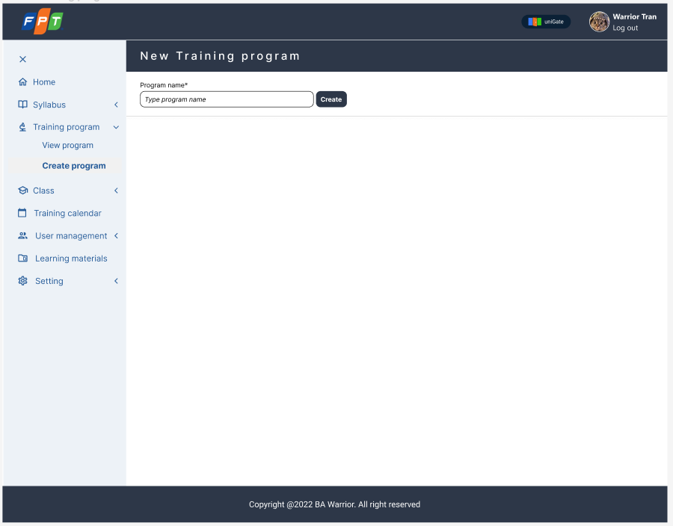

### Figure 3.1.7_1: Create Training Program

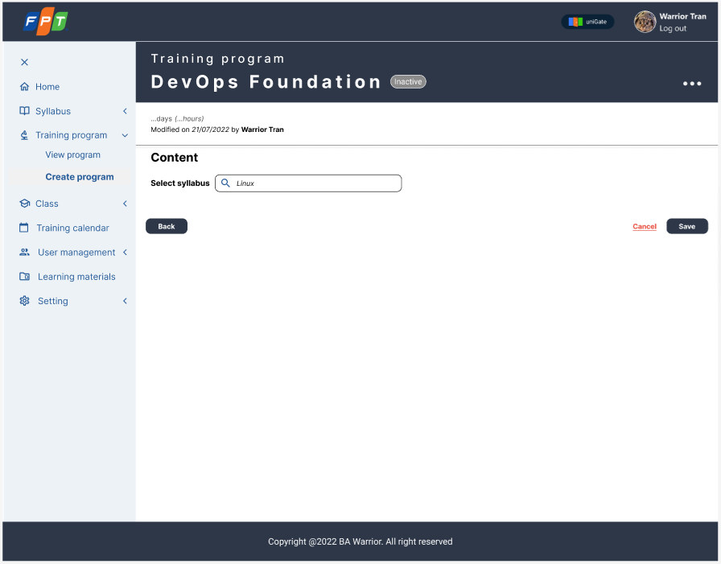

### Figure 3.1.7_2: Create Training Program_Add syllabus 1

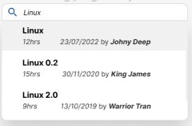

### Figure 3.1.7_3: Training Program_Syllabus popup

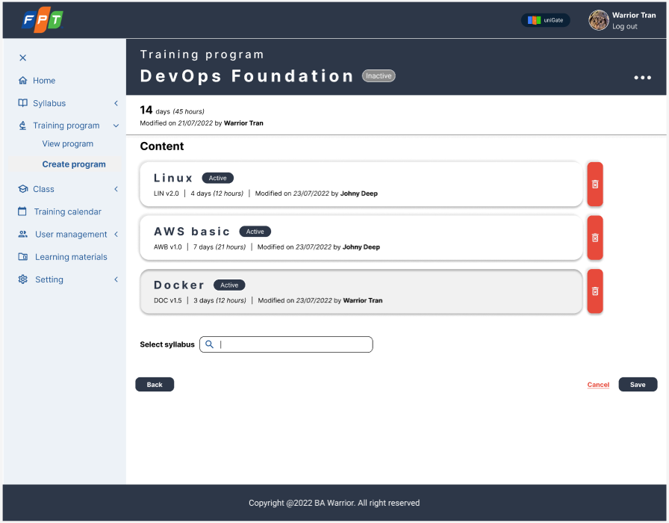

### Figure 3.1.7_4: Create Training Program_Add syllabus 2

|  |  |  |  |  |  |  |
| --- | --- | --- | --- | --- | --- | --- |
| Screen on web | Platform | Function | As a <type of user> | I want to <perform a task> | So that I can <achieve some goals> | Business rule |
| 7 | Web | Create new Training Program | End User | Create Training Program | Create new Training Programs  Search Syllabus  Drag & Drop Syllabus for Training Program | N/A |
|

### Table 3.1.7_1: User story

|  |  |  |  |  |  |  |  |  |
| --- | --- | --- | --- | --- | --- | --- | --- | --- |
| No | Screen item name | Type | Attribute | Length max | Display Yes/No | Input Yes/No | Required | Supplementary explanation |
| 1 | Type program name box | Textbox | - | × | ○ | ○ | ○ | - |
| 2 | Create button | Button | － | × | ○ | △ | ○ | [Ev01]  **[Process Flow]**  Step 1:  -The system shows item 3 with the name's typed  -The system shows item 4 with "Inactive" state  -The system shows item 6 with current date  -The system shows item 7 with current User's name |
| 3 | DevOps Foundation | Label | - | × | △ | × | △ | Show training program name |
| 4 | Active/Inactive | Tag | X | ○ | ○ | × | △ | Show training program status |
| 5 | Duration | Label | - | × | △ | × | △ | Total duration from total duration of selected syllabus |
| 6 | Modified on <create_date> | Calendar | 9 | ○ | △ | × | △ | Show created date |
| 7 | by <user_name> | Label | X | × | △ | × | △ | Show the user’s name who creates the Training Program |
| 8 | Select syllabus | Textbox | - | × | ○ | ○ | △ | [Ev02] **[Process Flow]**  Step 1: The system shows the syllabus corresponding to user typing |
| 9 | Back button | Button | － | × | △ | △ | △ | [Ev03] **[Process Flow]**  Step 1: The system back to the previous step in the screen |
| 10 | Save button | Button | － | × | △ | △ | △ | [Ev04] **[Process Flow]**  Step 1: The system creates Training Program with "inactive" status |
| 11 | Cancel button | button | － | × | △ | △ | △ | [Ev05] **[Process Flow]**  Step 1: Back to "List of Training Program" screen |
| 12 | Syllabus popup | Popup | - | × | △ | △ | △ | [Ev06] **[Process Flow]**  Step 1: User click on 1 syllabus  Step 2: The system shows item 5 as total duration of selected syllabus  Step 3: The system shows content of a syllabus |
| 13 | Syllabus name | Label | - | × | ○ | × | ○ | Name of syllabus |
| 14 | Duration | Label | - | × | △ | × | △ | The duration of syllabus |
| 15 | Modified on <create_date> | Calendar | 9 | ○ | △ | × | △ | Show created date of Syllabus |
| 16 | by <user_name> | Label | X | × | △ | × | △ | Show the user’s name who created the syllabus |
| 17 | DevOps Foundation | Label | - | × | △ | × | △ | Show training program name |
| 18 | Active/Inactive | Tag | X | ○ | ○ | × | △ | Show training program status |
| 19 | Duration | Label | - | × | △ | × | △ | Total duration from total duration of selected syllabus |
| 20 | Modified on <create_date> | Calendar | 9 | ○ | △ | × | △ | Show created date |
| 21 | by <user_name> | Label | X | × | △ | × | △ | Show the user’s name who creates the Training Program |
| 22 | Select syllabus | Textbox | - | × | ○ | ○ | △ | [Ev07] **[Process Flow]**  The system shows the syllabus corresponding to user typing |
| 23 | Syllabus name | Label | - | × | ○ | × | ○ | Name of syllabus |
| 24 | Duration | Label | - | × | △ | × | △ | The duration of syllabus |
| 25 | Modified on <create_date> | Calendar | 9 | ○ | △ | × | △ | Show created date of Syllabus |
| 26 | by <user_name> | Label | X | × | △ | × | △ | Show the user’s name who created the syllabus |
| 27 | Trash icon | Icon | - | x | △ | △ | △ | [Ev08] **[Process Flow]**  Step 1: User click on the button  Step 2: The system deletes the selected syllabus |
| 28 | Back button | Button | － | × | △ | △ | △ | [Ev09] **[Process Flow]**  The system back to the previous step in the screen |
| 29 | Save button | Button | － | × | △ | △ | △ | [Ev10] **[Process Flow]**  The system creates Training Program with "inactive" status |
| 39 | Cancel button | button | － | × | △ | △ | △ | [Ev11] **[Process Flow]**  Back to "List of Training Program" screen |

### Table 3.1.7_2: Item and event description

### 3.1.8. Use case 8: List of Class

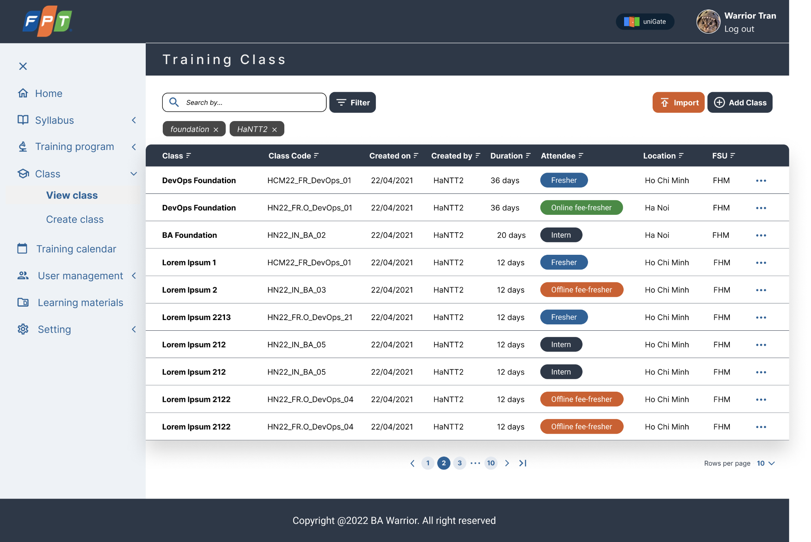

### Figure 3.1.8_1: List of Class

### Figure 3.1.8_2: Pop up Management of List of Class

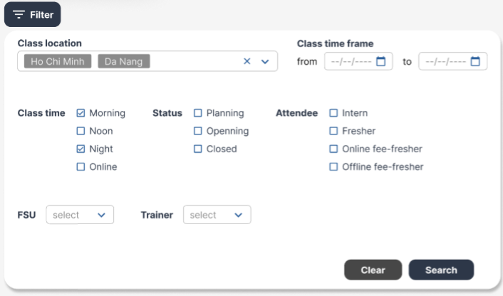

### Figure 3.1.8_3: Filter screen of List of Class

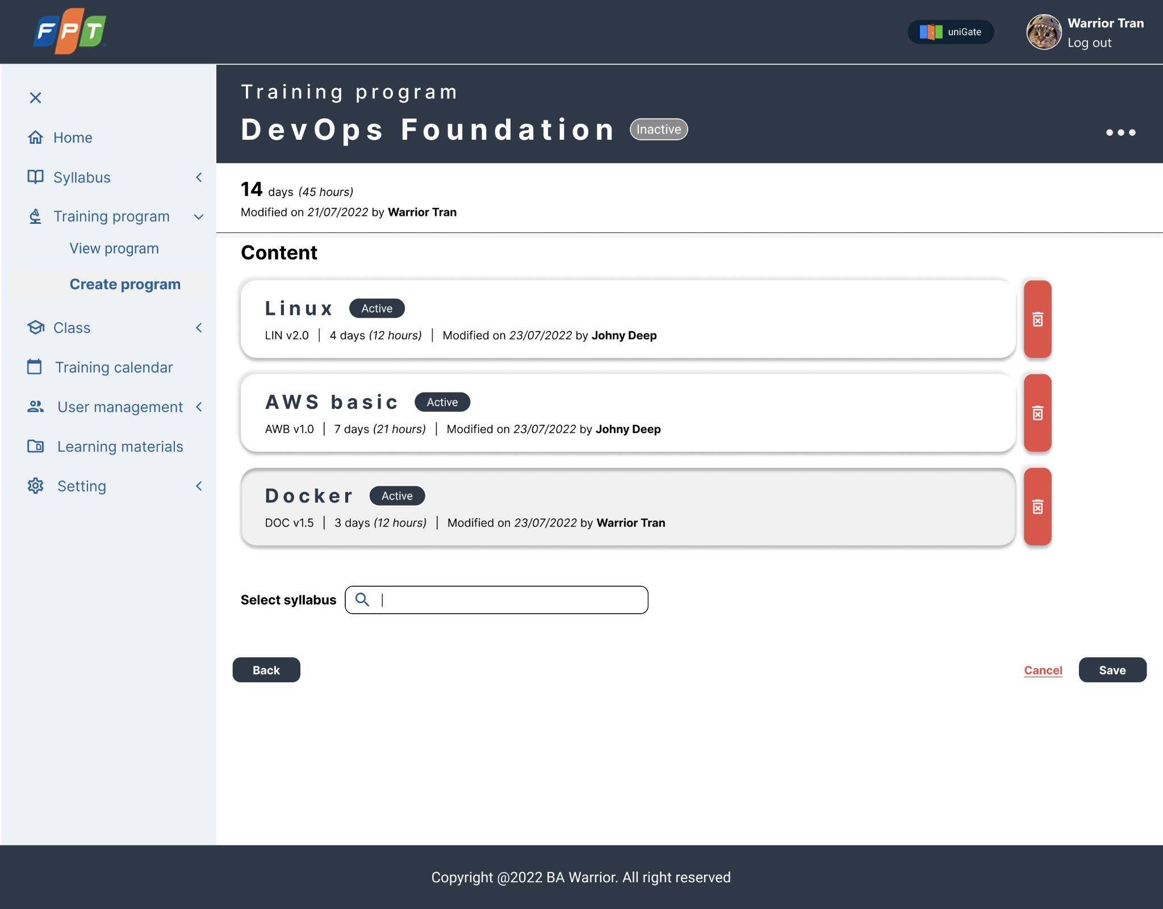

### Figure 3.1.8_4: Screen Edit of List of Class

|  |  |  |  |  |  |  |
| --- | --- | --- | --- | --- | --- | --- |
| Screen on web | Platform | Function | As a <type of user> | I want to <perform a task> | So that I can <achieve some goals> | Business rule |
| 1 | Web | View List of Class | End user | View details of List of Class | - Search class by Filter  - Duplicate class  - Edit Class  - Delete Class | N/A |
|

### Table 3.1.8_1: User story

|  |  |  |  |  |  |  |  |  |
| --- | --- | --- | --- | --- | --- | --- | --- | --- |
| No | Screen item name | Type | Attribute | Length max | Display Yes/No | Input Yes/ No | Required | Supplementary explanation |
| Filter feature & List of Training Class | | | | | | | | |
| 1 | Search by... | Textbox | × | 100 | ○ | ○ | × | Show up text for user input |
| 2 | Filter | Tooltip | - | - | ○ | × | × | Show up table filter |
| 3 | Class location | Combobox | - | - | ○ | × | △ | Just show default location |
| 4 | Supplier | Listbox | - | - | ○ | × | △ | Just show default supplier |
| 5 | Trainer | Listbox | - | - | ○ | × | △ | Just show trainer from database trainer |
| 6 | Class time frame | Label | - | - | ○ | × | × | Choose time frame |
| 7 | From | Calendar | dd/mm/yyyy | - | ○ | ○ | × | - |
| 8 | To | Calendar | dd/mm/yyyy | - | ○ | ○ | △ | - |
| 9 | Class time | Checkbox | - | - | ○ | × | △ | Just show 4 options: Morning, Noon, Night, Online |
| 10 | Status | Checkbox | - | - | ○ | × | △ | Just show 3 options: Planning, Opening, Closed |
| 11 | Clear | Button | - | - | ○ | × | × | [Ev01] **[Process Flow]**  Step 1: Click on will clear all input data in table filter |
| 12 | Search | Button | - | - | ○ | × | × | [Ev02] **[Process Flow]**  Step 1: Click on will search for suggestions from input data. After searching will show up in class according to searching + on July 2022. Show up arrow down icon for choosing row per page will show up |
| 13 | Previous, Next  < > | Button | - | - | ○ | × | △ | [Ev03] **[Process Flow]**  Step 1: Click on for moving next page of searching result |
| 14 | Import | Button | - | - | ○ | × | × | Import list of class in default format form |
| 15 | Add Class | Button | - | - | ○ | × | × | [Ev04] **[Process Flow]**  Step 1: Click on the Add Class button will go to screen Add new |
| 16 | Attendee | Checkbox | - | - | ○ | × | △ | Just show 4 options of attendee type to choose |
| Training Class Detail Pop up Management | | | | | | | | |
| 17 | Edit Class | Button | - | - | ○ | × | × | [Ev05] **[Process Flow]**  Step 1: Click on the Edit Class button will go to screen Edit |
| 18 | Duplicate | Button | - | - | ○ | × | × | [Ev06] **[Process Flow]**  Step 1: Click on the Duplicate button, user will go to screen Edit BUT Class name change with the title: “Copy of…….” |
| 19 | Delete | Button | - | - | ○ | × | × | [Ev07] **[Process Flow]**  Step 1: Click on the Delete button, user will delete the syllabus |

### Table 3.1.8_2: Item and event description

### 3.1.9. Use case 9: Training Class Details

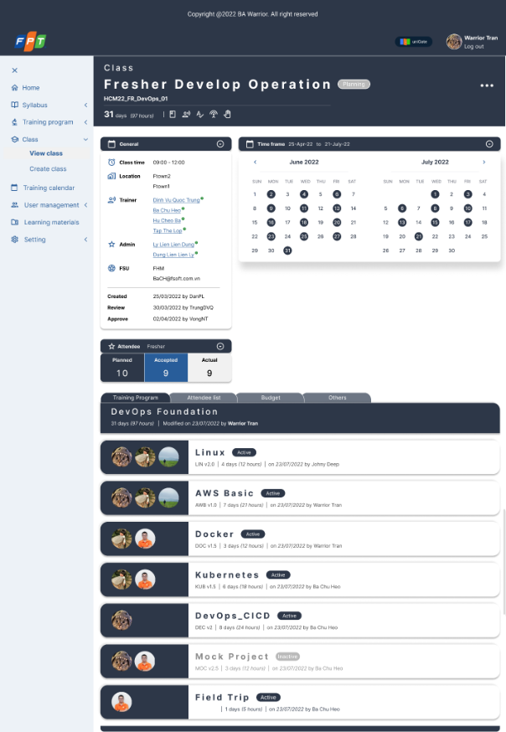

**Figure 3.1.9_1: Training Class Details**

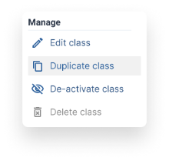

### Figure 3.1.9_2: Manage a Training Class

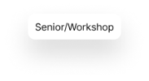

### Figure 3.1.9_3: Delivery Type Tooltip

### 

### Figure 3.1.9_4: Trainer Information Tooltip

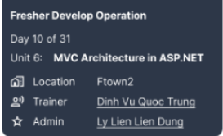

### Figure 3.1.9_5: Class Detail Tooltip

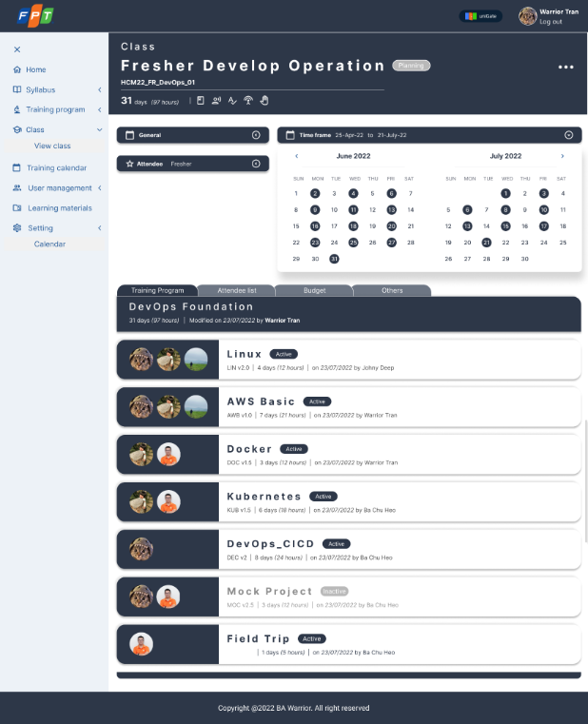

### Figure 3.1.9_6: Class Detail Collapse

|  |  |  |  |  |  |  |
| --- | --- | --- | --- | --- | --- | --- |
| Screen on web | Platform | Function | As a <type of user> | I want to <perform a task> | So that I can <achieve some goals> | Business rule |
| 8 | Web | Training Class details | End user | View Training Class details | -View Training Class details  -Edit Training Class  -Duplicate Training Class  -De-active syllabus  -Delete Training Class | N/A |
|

### Table 3.1.9_1: User story

|  |  |  |  |  |  |  |  |  |
| --- | --- | --- | --- | --- | --- | --- | --- | --- |
| No | Screen item name | Type | Attribute | Length  Max | Display  Yes/ No | Input  Yes/ No | Required | Supplementary explanation |
| 1 | Class | Label | X | 5 | ○ | x | x | Display the Module name |
| 2 | Class name | Label | X | 80 | ○ | x | x | Display Class name. |
| 3 | Class code | Label | X | 40 | ○ | x | x | Display Class code. |
| 4 | Class Status | Label | X | 20 | ○ | x | x | Display Class Status.  Value list: Planning, Opening, Closed  Default value: Planning |
| 5 | Class Manage | Dropdown-list | - | - | ○ | x | x | [Ev01] **[Process Flow]**  Step 1: User clicks on the "Class manage"  Step 2: System shows a list of options |
| 6 | Class Duration | Label | Format value:  x days (y hours)  x: total days of Class  y: total hours of Class | 20 | ○ | x | x | Display duration of a Class. |
| 7 | Delivery Type | Icon | - | - | ○ | x | x | [Ev02] **[Process Flow]**  Step 1: Hover the mouse to a certain Delivery Type Icon  Step 2: The system shows The Delivery Type Detail Tooltip (Level/ Program Type) |
| Class manage popup (Figure 3.1.9_2) | | | | | | | | |
| 8 | Manage | Label | - | - | △ | x | x | Display the pop-up name |
| 9 | Edit Class | Button | - | - | △ | x | x | [Ev03] **[Process Flow]**  Step 1: [Ev1]  Step 2: User clicks on the "Edit class" feature appearing on the list  Step 3: System navigate to Edit Class screen |
| 10 | Duplicate Class | Button | - | - | △ | x | x | [Ev04] **[Process Flow]**  Step 1: The user clicks on the "Duplicate Class" feature appearing on the list  Step 2: System shows screen Class Detail with Class name duplicate with a New Name  Name of new Class: Copy of [Class name] |
| 11 | De-active Class | Button | - | - | △ | x | x | [Ev05] **[Process Flow]**  Step 1: On click, Class status is changed from Planning to Closed. |
| 12 | Delete Class | Button | - | - | △ | x | x | Button only available for users with certain role permissions.  [Ev06] **[Process Flow]**  Step 1: User clicks on the "Delete Class" feature appearing on the list  Step 2: The screen appears as a confirmation box.  Step 3: If the User selects Yes, the system will soft-delete the Class. If the User select No, the box will disappear and the user will return to Class Detail Screen |
| Delivery Type tooltip (Figure 3.1.9_3) | | | | | | | | |
| 13 | Level/ Program Type | Label | X | 20 | △ | x | x | [Ev07] **[Process Flow]**  Step 1: Hover the mouse to a certain Delivery Type Icon  Step 2: The system shows The Delivery Type Detail Tooltip (Level/ Program Type)  Data is retrieved from Master Data. |
| Tab General | | | | | | | | |
| 14 | General | Label | - | - | ○ | x | x | Display the Tab name |
| 15 | Collapse | Button | - | - | ○ | x | x | [Ev08] **[Process Flow]**  Step 1: The user clicks on the collapse button of the tabs they want to hide detailed information  Step 2: Depending on which button the user clicks, the field containing that button will be collapsed |
| 16 | Class Time | Label | Format: hh:mm  h: hour  m: minute | 20 | ○ | x | x | Display the Start time and End time of a Class |
| 17 | Location | Label | X | 20 | ○ | x | x | Display where the class takes place |
| 18 | Trainer | Tooltip | X | 80 | ○ | x | x | Display the trainers' names responsible for a class.  There can be more than one trainer for a class  [Ev09] **[Process Flow]**  Step 1: Hover the mouse to a trainer's name  Step 2: The system shows Trainer Information Tooltip for that trainer |
| 19 | Admin | Label | X | 80 | ○ | x | x | Display the admins' names responsible for a class.  There can be more than one admin for a class |
| 20 | FSU | Label | X | - | ○ | x | x | Display the FSU organizing a class |
| 21 | Created | Label | X | 80 | ○ | x | x | Display the Class Creator's name |
| 22 | Review | Label | X | 80 | △ | x | x | Display the Class Reviewer's name  Only display when the class has been reviewed |
| 23 | Approved | Label | X | 80 | △ | x | x | Display the Class Approver's name  Only display when the class has been approved |
| Trainer information Tooltip (Figure 3.1.9_4) | | | | | | | | |
| 24 | Mobile phone | Label | 9 | 10 | △ | x | x | Display trainer's mobile phone |
| 25 | Email | Label | X | 40 | △ | x | x | Display trainer's email |
| Tab Time Frame | | | | | | | | |
| 26 | Time Frame | Label | X | 20 | ○ | x | x | Display the Tab name |
| 27 | Class Start and End Date | Label | Format: dd-mmm-yy  d: Date  m: Month  y: Year | 80 | ○ | x | x | Display the Start Date and End Date of a Class |
| 28 | Collapse | Button | - | - | - | - | - | [Ev10] **[Process Flow]**  Step 1: The user clicks on the collapse button of the tabs they want to hide detailed information  Step 2: Depending on which button the user clicks, the field containing that button will be collapsed |
| 29 | Calendar | Calendar | - | - | ○ | x | x | Highlight all the dates a class occurring |
| 30 | Month Year | Label | X | 20 | ○ | x | x |  |
| 31 | Normal Date | Label | X | 2 | ○ | x | x |  |
| 32 | Highlighted date | Tooltip | X | 2 | △ | x | x | [Ev11] **[Process Flow]**  Step 1: hover the mouse to a highlighted date in the Calendar  Step 2: System displays the Class detail tooltip for that date |
| Class Detail Tooltip (Figure 3.1.9_5) | | | | | | | | |
| 33 | Class Name | Label | X | 80 | △ | x | x | Display the Class name |
| 34 | Date order | Label | Format: Day X of Y  X: Current Date order  Y: total dates of the class | - | △ | x | x | Display the Date order out of the total dates of the class |
| 35 | Training Program Unit | Label | X | - | △ | x | x | Display the Unit taught on that date |
| 36 | Location | Label | X | - | △ | x | x | Display where the class takes place |
| 37 | Trainer | Label | X | - | △ | x | x | Display the trainer's name |
| 38 | Admin | Label | X | - | △ | x | x | Display the admin's name |
| Tab Attendee | | | | | | | | |
| 39 | Attendee | Label | X | 20 | ○ | x | x | Display the Tab name |
| 40 | Fresher | Label | X | 20 | ○ | x | x | Display the Student Type |
| 41 | Planned | Label | 9 | 3 | ○ | x | x | Display the number of planned students joining a class |
| 42 | Accepted | Label | 9 | 3 | ○ | x | x | Display the number of accepted students for a class |
| 43 | Actual | Label | 9 | 3 | ○ | x | x | Display the number of actual students joining a class |
| Tab Training Program | | | | | | | | |
| 44 | Training Program | Label | X | 20 | ○ | x | x | Display the Tab name |
| 45 | Training Program Name | Label | X | 80 | ○ | x | x | Display the Training Program name |
| 46 | Training Program Duration | Label | Format value:  x days (y hours)  x: total days of Class  y: total hours of Class | 20 | ○ | x | x | Display duration of a Training Program. |
| 47 | Last edit Date | Label | Format: dd/mm/yyyy | - | ○ | x | x | Display the last edit date of a Training Program |
| 48 | Editor | Label | Format: By X  X: User name | - | ○ | x | x | Display the last editor's name |
| Syllabuses Detail | | | | | | | | |
| 49 | Trainer's avatar | Picture | - | - | ○ | x | x | Display the trainer's profile picture  There can be more than one picture |
| 50 | Syllabus's name | Label | X | 80 | ○ | x | x | Display the syllabus's name |
| 51 | Syllabus's status | Label | X | 20 | ○ | x | x | Display the syllabus's status  Value: Active/ Inactive |
| 52 | Syllabus's short name | Label | X | 10 | ○ | x | x | Display syllabus's short name |
| 53 | Syllabus Duration | Label | Format value:  x days (y hours)  x: total days of Class  y: total hours of Class | 20 | ○ | x | x | Display the duration of a Syllabus. |
| 54 | Last edit Date | Label | Format: dd/mm/yyyy | - | ○ | x | x | Display the last edit date of a Syllabus |
| 55 | Editor | Label | Format: By X  X: User name | - | ○ | x | x | Display the last editor's name |

### Table 3.1.9_2: Item and event description

### 3.1.10. Use case 10: Create new training class

### 

### Figure 3.1.10_1: Create class name

|  |  |  |  |  |  |  |
| --- | --- | --- | --- | --- | --- | --- |
| Screen on web | Platform | Function | As a <type of user> | I want to <perform a task> | So that I can <achieve some goals> | Business rule |
| 9 | Web | Add new class | End user | Create new class | Start add detail and information | N/A |

### Table 3.1.10_1: User story

|  |  |  |  |  |  |  |  |  |
| --- | --- | --- | --- | --- | --- | --- | --- | --- |
| No | Screen item name | Type | Attribute | Length max | Display  Yes/No | Input  Yes/No | Required | Supplementary explanation |
| 1 | Class | Label | x | 5 | ○ | x | x | Module name |
| 2 | Class name | Label | x | 80 | ○ | x | x | Class name |
| 3 | Text box | Text box | x | 80 | ○ | ○ | ○ | Default value: “Type class name” |
| 4 | Create | Button | x | x | ○ | x | x | After user selects Create button, system shows Add training program |

### 

### Figure 3.1.10_2: Add training program general information

|  |  |  |  |  |  |  |  |  |
| --- | --- | --- | --- | --- | --- | --- | --- | --- |
| No | Screen item name | Type | Attribute | Length max | Display  Yes/No | Input  Yes/No | Required | Supplementary explanation |
| 1 | Class | Label | x | 5 | ○ | x | x | Module name |
| 2 | Class name | Label | x | 80 | ○ | x | x | Display the value user input in Create class |
| 3 | Class Status | Label | x | 15 | ○ | x | x | Display current status of class “Planning, Opening, Closed” |
| 4 | Days | Label | x | 5 | ○ | x | x | Total duration in day of that class |
| 5 | hours | Label | x | 5 | ○ | x | x | Total duration in hours of that class |
| General | | | | | | | | |
| 6 | Class time | Label | Format: hh:mm – hh:mm  h: hour  m: minute | 20 | ○ | x | x | Display the Start time and End time of a Class |
| 7 | From | Time picker | h: hour  m: minute | 20 | ○ | x | x | Display in hours and minutes |
| 8 | To | Time picker | h: hour  m: minute | 20 | ○ | x | x | Display in hours and minutes |
| 9 | Location | Label | x | 20 | ○ | x | x | Display where the class takes place |
| 10 | Trainer | Tooltip | x | 80 | ○ | x | x | Display the trainers' names responsible for a class.  There can be more than one trainer for a class  **[Process Flow]**  Step 1: Hover the mouse to a trainer's name  Step 2: The system shows Trainer Information Tooltip for that trainer |
| 11 | Admin | Combobox | x | 80 | ○ | x | x | Display the admins' names responsible for a class.  There can be more than one admin for a class |
| 12 | FSU | Combobox | x | - | ○ | x | x | Display the FSU organizing a class |
| 13 | Contact Point | Combobox | x | - | ○ | x | x | Choose contact point |
| 14 | Created | Label | x | 80 | ○ | x | x | Display the Class Creator's name |
| 15 | Review | Label | x | 80 | △ | x | x | Display the Class Reviewer's name  Only display when the class has been reviewed |
| 16 | Approve | Label | x | 80 | △ | x | x | Display the Class Approver's name  Only display when the class has been approved |
| Time Frame | | | | | | | | |
| 17 | Start date | Label | Format: dd-mmm-yyyy  d: Date  m: Month  y: Year | 80 | ○ | x | x | Display the Start Date and End Date of a Class |
| 18 | End date | Label | Format: dd-mmm-yyyy  d: Date  m: Month  y: Year | 80 | ○ | x | x | Display the Start Date and End Date of a Class |
| 19 | Calendar | Calendar | - | - | Yes | x | x | Highlight all the dates a class occurring |
| Attendee | | | | | | | | |
| 20 | Level | Dropdown list | X | 20 | ○ | x | x | Display the Student Type |
| 21 | Planned | Textbox | 9 | 3 | ○ | x | x | Display the number of planned students joining a class |
| 22 | Accepted | Textbox | 9 | 3 | ○ | x | x | Display the number of accepted students for a class |
| 23 | Actual | Textbox | 9 | 3 | ○ | x | x | Display the number of actual students joining a class |
| 24 | Training Program | Tab | X | x | ○ | x | x | Expand the selected tab |
| 25 | Edit | Button | - | x | ○ | x | x | Edit training program name |
| 26 | Attendee list | Tab | X | x | ○ | x | x | Expand the selected tab |
| 27 | Budget | Tab | X | x | ○ | x | x | Expand the selected tab |
| 28 | Others | Tab | X | x | ○ | x | x | Expand the selected tab |
| 29 | Cancel | Button | X | x | ○ | x | x | Back to List of Class |
| 30 | Save as draft | Button | X | x | ○ | x | x | Save |
| 31 | Next | Button | X | x | ○ | x | x | Move to Add training program details |

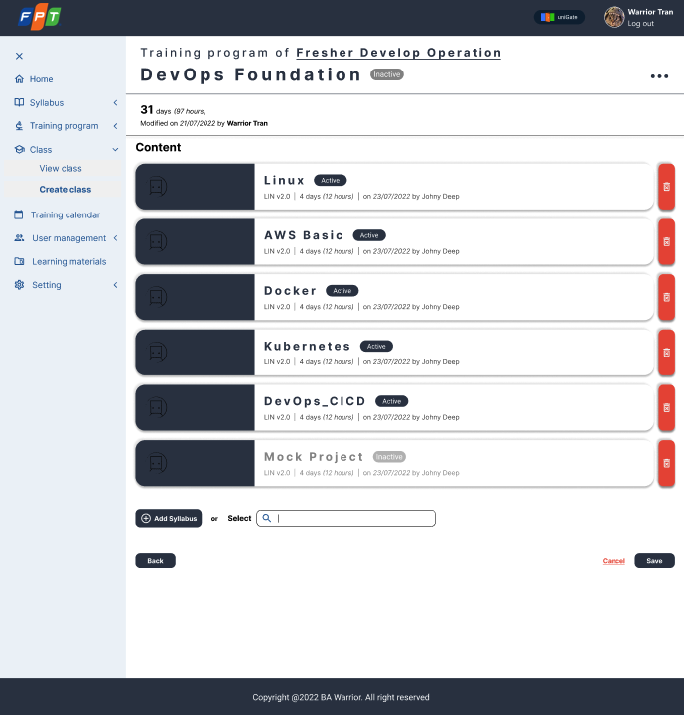

### Figure 3.1.10_3: Add training program details

|  |  |  |  |  |  |  |  |  |
| --- | --- | --- | --- | --- | --- | --- | --- | --- |
| No | Screen item name | Type | Attribute | Length max | Display  Yes/No | Input  Yes/No | Required | Supplementary explanation |
| 1 | Last edit Date | Label | Format: dd/mm/yyyy | - | Yes | No | No | Display the last edit date of a Training Program |
| 2 | Editor | Label | Format: By X  X: User name | - | Yes | No | No | Display the last editor's name |
| Add syllabus | | | | | | | | |
| 3 | Trainer's avatar | Picture | - | - | Yes | No | No | Display the trainer's profile picture  There can be more than one picture |
| 4 | Syllabus's name | Label | X | 80 | Yes | No | No | Display the syllabus's name |
| 5 | Syllabus's status | Label | X | 20 | Yes | No | No | Display the syllabus's status  Value: Active/ Inactive |
| 6 | Syllabus's short name | Label | X | 10 | Yes | No | No | Display syllabus's short name |
| 7 | Syllabus Duration | Label | Format value:  x days (y hours)  x: total days of Class  y: total hours of Class | 20 | Yes | No | No | Display the duration of a Syllabus. |
| 8 | Last edit Date | Label | Format: dd/mm/yyyy | - | Yes | No | No | Display the last edit date of a Syllabus |
| 9 | Editor | Label | Format: By X  X: User name | - | Yes | No | No | Display the last editor's name |
| 10 | Delete | Button | x | x | Yes | No | No | Delete one syllabus |
| 11 | Add Syllabus | Button | x | x | Yes | No | No | Add new |
| 12 | Select | Textbox | x | x | Yes | No | No | User can input to search available syllabus |
| 13 | Back | Button | x | x | Yes | No | No | Previous step with saving new changes |
| 14 | Cancel | Button | x | x | Yes | No | No | Previous step without saving. |
| 15 | Save | Button | x | x | Yes | No | No | Display **Add training program details for each Day** |

### 

### 

### 

### 

### 

### 

### 

### 

### 

### 

### 

### 

### 

### 

### 

### Figure 3.1.10_4: Add training program details for each Day (Content)

|  |  |  |  |  |  |  |  |  |
| --- | --- | --- | --- | --- | --- | --- | --- | --- |
| No | Screen item name | Type | Attribute | Length max | Display  Yes/No | Input  Yes/No | Required | Supplementary explanation |
| 1 | Syllabus name | Label | X | 80 | ○ | × | ○ | Display the syllabus's name |
| 2 | Day number | Label | X | 5 | ○ | × | ○ | Display the day number |
| 3 | Unit number | Label | X | 3 | ○ | × | ○ | Display the unit number |
| 4 | Name of the unit | Label | X | 50 | ○ | × | ○ | Display the name of the unit |
| 5 | Duration of that unit | Label | X | 5 | ○ | × | ○ | Display the duration of that unit |
| 6 | Topic for training name | Label | X | 80 | ○ | × | ○ | Display the topic for training name |
| 7 | Duration for each topic | Label | X | 5 | ○ | × | ○ | Display the duration for each topic |
| 8 | Status (online/offline) | Label | X | 20 | ○ | × | ○ | Display the status of the class |
| 9 | Trainer account | Label | X | 30 | ○ | × | ○ | Display the trainer account |
| 10 | Location for each unit | Label | X | 30 | ○ | × | ○ | Display the location for each unit |

### 3.1.11. Use case 11: Training Calendar

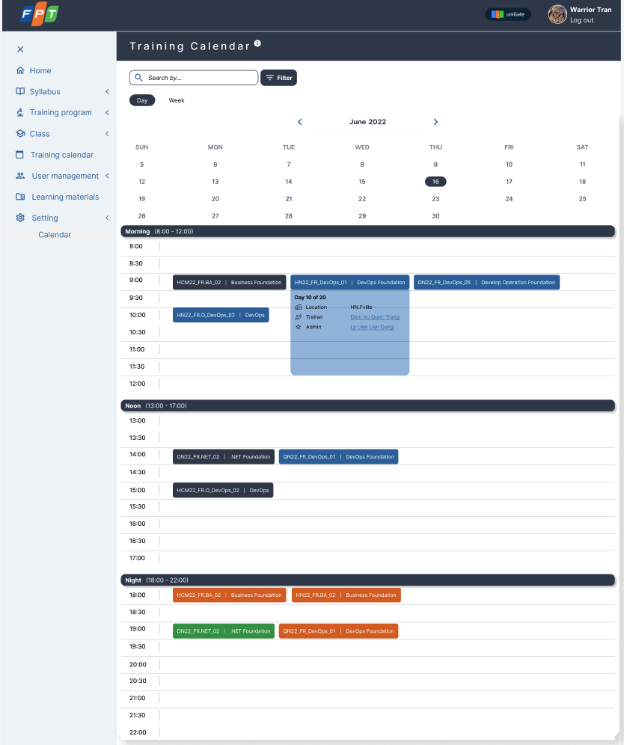

### Figure 3.1.11_1: Training Calendar main view

|  |  |  |  |  |  |  |
| --- | --- | --- | --- | --- | --- | --- |
| Screen on web | Platform | Function | As a <type of user> | I want to <perform a task> | So that I can <achieve some goals> | Business rule |
| 10 | Web | Calendar | End user | See the training Calendar | Manage, tracking and follow up all classes that be added on in created class | N/A |
|

### Table 3.1.11_1: User story

|  |  |  |  |  |  |  |  |  |
| --- | --- | --- | --- | --- | --- | --- | --- | --- |
| No | Screen item name | Type | Attribute | Length max | Display  Yes/No | Input  Yes/No | Required | Supplementary explanation |
| Training Calendar main view | | | | | | | | |
| 1 | Search by... | Textbox | - | 100 | ○ | ○ | × | [Ev01] **[Process Flow]**  Step 1: User input information that they want to search  Step 2: Search all the class according to the input information |
| 2 | Filter | Tooltip | - | - | ○ | × | × | [Ev02] **[Process Flow]**  Step 1: Click on Filter  Step 2: Show up the table filter |
| 3 | Day | Button | - | - | ○ | × | × | A tab to search class by day |
| 4 | Week | Button | - | - | ○ | × | × | A tab to search class by week |
| 5 | June 2022 | Button | - | - | ○ | × | △ | Month and Year user want to search, User can input and choose the time they want |
| 6 | Previous, Next  < > | Button | - | - | ○ | × | △ | [Ev03] **[Process Flow]**  Step 1: Click on to <>  Step 2: Search move backward or forward  1 click is 1 month move |
| 7 | Calendar Base | Table | - | - | ○ | × | ○ | Show the day in month  When user click on 1 day, will show all class based on which tab they choose  [Ev04] **[Process Flow]**  Step 1: Choose Tab Day, Click on 1 day  Step 2: Will show all classes on this day.  [Ev05] **[Process Flow]**  Step 1: Choose Tab Week - Click on 1 day  Step 2: Will show all class in the week contains this day |
| 8 | Session Time  Morning/Noon/Night | Label | - | - | ○ | × | △ | Show up the class’s session which is based on the user's search.  Morning: (8:00-12:00)  Noon: (13:00-17:00)  Night: (18:00-22:00)  When user roll down, the session time will short up (just keep the bar Morning/ Noon/ Night) |

### Table 3.1.11_2: Item and event description

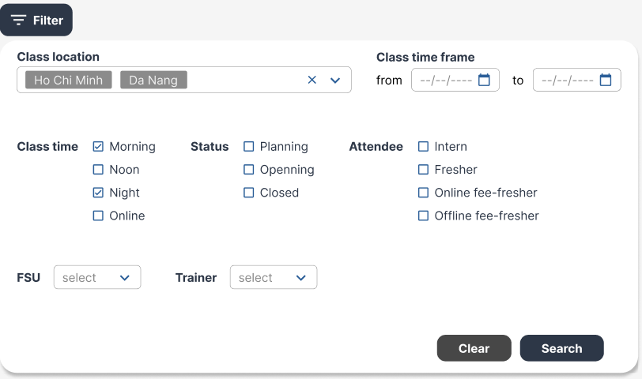

### Figure 3.1.11_2: Table Filter

|  |  |  |  |  |  |  |  |  |
| --- | --- | --- | --- | --- | --- | --- | --- | --- |
| No | Screen item name | Type | Attribute | Length max | Display  Yes/No | Input  Yes/No | Required | Supplementary explanation |
| Table Filter | | | | | | | | |
| 1 | Class location  (In table Filter) | Combobox | - | - | ○ | × | △ | [Ev08] **[Process Flow]**  Step 1: Input the location information  Step 2: Show up suggestion location that be input already such as HCM, DN, HN |
| 2 | FSU | Listbox | - | - | ○ | × | △ | [Ev09] **[Process Flow]**  Step 1: Input the Supplier information  Step 2: Show up suggestion supplier which be input before |
| 3 | Trainer | Listbox | - | - | ○ | × | △ | [Ev10] **[Process Flow]**  Step 1: Input the trainer information  Step 2: Show up suggestion trainer which be input before |
| 4 | Class time frame | Label | - | - | ○ | × | × | Display the information that it’s time frame |
| 5 | From | Calendar | dd/mm/yyyy | - | ○ | ○ | × | User choose the date to start the class. |
| 6 | To | Calendar | dd/mm/yyyy | - | ○ | ○ | △ | User choose the date to end the class. |
| 7 | Class time | Checkbox | - | - | ○ | × | △ | [Ev11] **[Process Flow]**  Step 1: User can choose the class time in morning, afternoon, evening, online  Step 2: Show the tick on chosen time |
| 8 | Status | Checkbox | - | - | ○ | × | △ | [Ev12] **[Process Flow]**  Step 1: User can choose the status  Step 2: Show the tick on chosen time |
| 9 | Attendee | Checkbox | - | - | ○ | × | △ | [Ev13] **[Process Flow]**  Step 1: User can choose the attendee  Step 2: Show the tick on chosen time |
| 10 | Clear | Button | - | - | ○ | × | × | [Ev14] **[Process Flow]**  User click on and clear all information that be input before in table filer |
| 11 | Search | Button | - | - | ○ | × | × | [Ev15] **[Process Flow]** User click on and search all classes that match these input information |

### Table 3.1.11_3: Item and event description

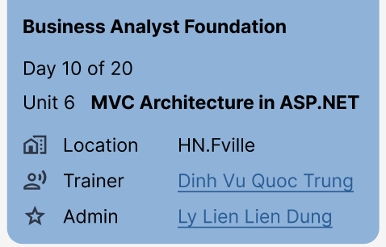

### Figure 3.1.11_3: Class info - view

|  |  |  |  |  |  |  |  |  |
| --- | --- | --- | --- | --- | --- | --- | --- | --- |
| No | Screen item name | Type | Attribute | Length max | Display  Yes/No | Input  Yes/No | Required | Supplementary explanation |
| **Class info - view** | | | | | | | | |
| 1 | Business Analyst Foundation | Label | - | - | ○ | × | × | Display the class name which format:  Class code | Class name |
| 2 | Order of class session in total | Label | - | - | ○ | × | △ | Display the order of the day that class is running per total number of days that class may happen.  Example: “Day 10 of 20” (the day 10th out of the total number day in class which is 20)  Min: 0 max: 100 |
| 3 | Course Unit | Label | - | - | ○ | × | △ | Display the course’s unit in this day that be input in create class |
| 4 | Location | Label | - | - | ○ | × | △ | Display the Location that be input in create class |
| 5 | Trainer | Label | - | - | ○ | × | △ | Display the Trainer that be input in create class |
| 6 | Admin | Label | - | - | ○ | × | △ | Display the Admin that be input in create class |

### Table 3.1.11_4: Item and event description

### 3.1.12. Error message

|  |  |  |
| --- | --- | --- |
| **No.** | **Screen** | **Error message** |
| EM01 | Login | Invalid username or password |
| EM02 | Required field! |
| EM03 | Forgot password | Required field! |
| EM04 | Matched new password and confirm password |
| EM05 | Send email to FA HCM | Existed email |
| EM06 | Required field! |
| EM07 | Import | Unsupported file type |
| EM08 | Incorrect file size |
| EM09 | Create Syllabus | Required field! |
| EM10 | Sudden exit |
| EM11 | Warning message - delete unit |
| EM12 | Add Training Program | Required field! |
| EM13 | Modified program alert |
| EM14 | Sudden exit |
| EM15 | Warning message - delete day |
| EM16 | Warning message - deactivate program |
| EM17 | Create class | Required field! |
| EM18 | Sudden exit |
| EM19 | Warning message - deactivate class |
| EM20 | User management | Unsupported file type |
| EM21 | Incorrect file size |
| EM22 | Required field! |
| EM23 | Warning message - delete user |
| EM24 | Warning message - deactivate user |

## 3.2. Usability

Followed by UI/UX rules to design the system. Make sure users can easily use the system without any training before.

## 3.3. Reliability

System should provide reliable and relevant search results 100% of times

## 3.4. Performance

For the number of users increase or decrease, it still does not affect the tasks (performance) of the application. It has maximum 8s to load a page and search a result displayed within 5s.

## 3.5. Supportability

This system supports interface interaction with Fsoft authentication. It’s also supported to import and export files in excel, doc, pdf, and attach the other website links.

## 3.6. Permission Management

The application should provide the permission setting tool. This allows users with high permission to add roles and permission by themselves. If were developed, it should be as those screens below:

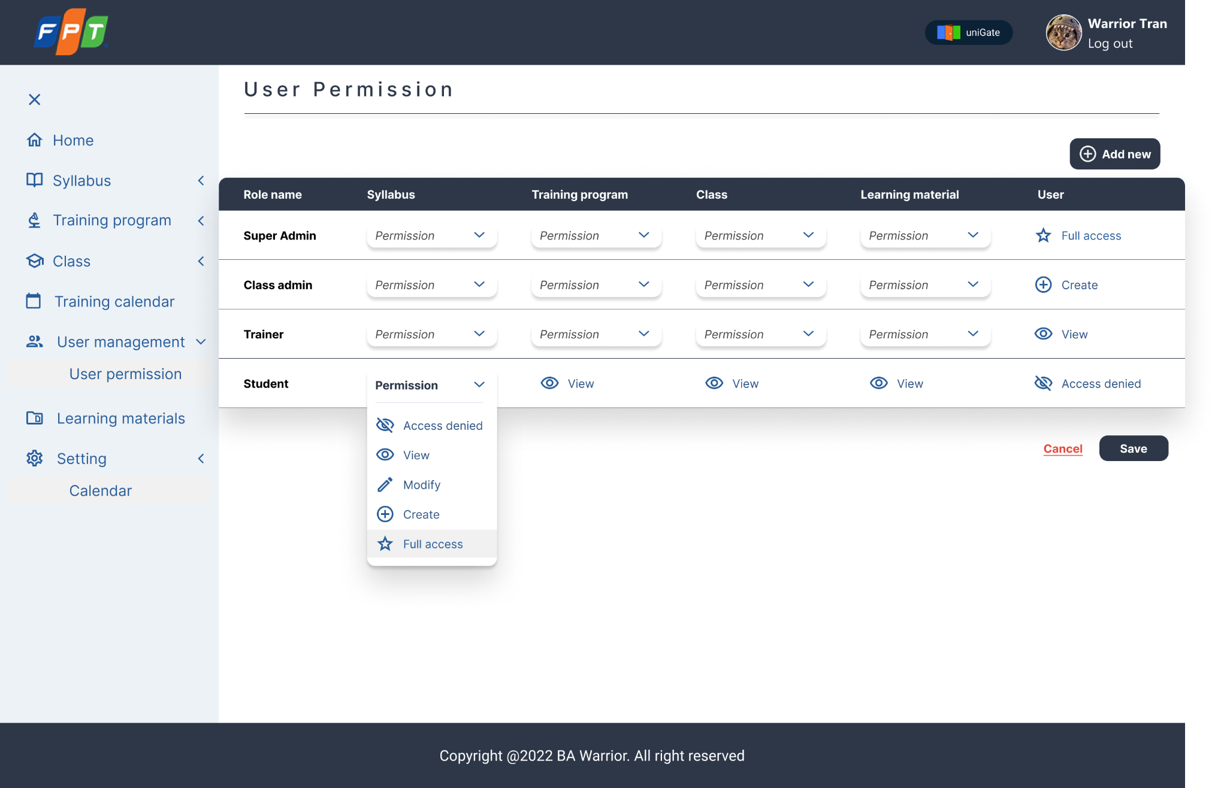

## 3.7. Legal, Copyright, and Other Notices

The application’s legal, copyright and other notices belong to Fresher Academy.

## 3.8. Non-functional requirements

|  |  |
| --- | --- |
| Response Time and Net Processing Time | Response within 5s |
| Operation time | 24/7 |
| Business continuity requirements | In disaster case, system can recover data |
| Data recovery range | Can recover data up to 24h ago |
| Number of concurrent users | 1000 |
| Secure coding, web server setting | Implement measures against threats and vulnerabilities specific to web applications |
| Session timeout | 30 mins |

# 4. OUT OF SCOPE

The following the object is out of scope of this SRS:

* User management includes trainer, trainee
* Class management
* Import template
* Cost, budget management
* External system for user authentication
* Settings